

**AWS Project**

**Team: TITANS**

Harshith Raj

Vinayak Pote

Yathish Kumar

Nitish Kumar Singh

**INDEX**

**Part-1**

|  |  |  |
| --- | --- | --- |
| **Sl No.** | **Topic** | **Pg No.** |
| 1. | Creating VPC-1 | 4 |
| 2. | Creating subnets | 4-5 |
| 3. | Creating Internet Gateway | 5 |
| 4. | Creating Route Table | 6-7 |
| 5. | Creating NAT Gateway | 8 |
| 6. | Creating Private Route | 8-9 |
| 7. | Creating Security Groups | 9 |
| 8. | Creating Instances | 10 |
| 9. | Connecting to EC2 | 11 |
| 10. | Testing EC2 | 11 |
| 11. | Creating AMI | 12 |
| 12. | Creating Template | 12 |
| 13. | Creating AutoScaling Group | 12-14 |
| 14. | Creating RDS | 15 |
| 15. | Creating S3 bucket | 16 |
| 16. | Creating DynamoDB table | 16 |
| 17. | Data Getting uploaded on DynamoDB table | 17-18 |
| 18. | Creating role for S3 | 19 |
| 19. | Mounting S3 bucket on EC2 instance | 19-20 |
| 20. | Output | 20 |

**Part-2**

|  |  |  |
| --- | --- | --- |
| 1. **Connecting S3 to Athena using Glue** | | |
| **Sl No.** | **Topic** | **Pg No.** |
| 1. | Creating buckets | 21 |
| 2. | Creating Crawlers | 22 |
| 3. | Creating workgroup in Athena | 22 |
| 4. | Selecting database and running query | 23 |
| 5. | Output | 23 |
|  |  |  |
| 1. **Connecting S3 to Redshift using Glue** | | |
| 1. | Creating VPC Peering | 24 |
| 2. | Creating EFS | 24-25 |
| 3. | Mounting EFS on instances. | 26 |
| 4. | Creating S3 bucket with dataset | 26 |
| 5. | Creating Redshift cluster | 27 |
| 6. | Making the connection for query builder | 27 |
| 7. | Creating 1st crawler for S3 bucket | 28 |
| 8. | Creating connection for Redshift | 28-29 |
| 9. | Output | 30 |

**Part-1**

1. 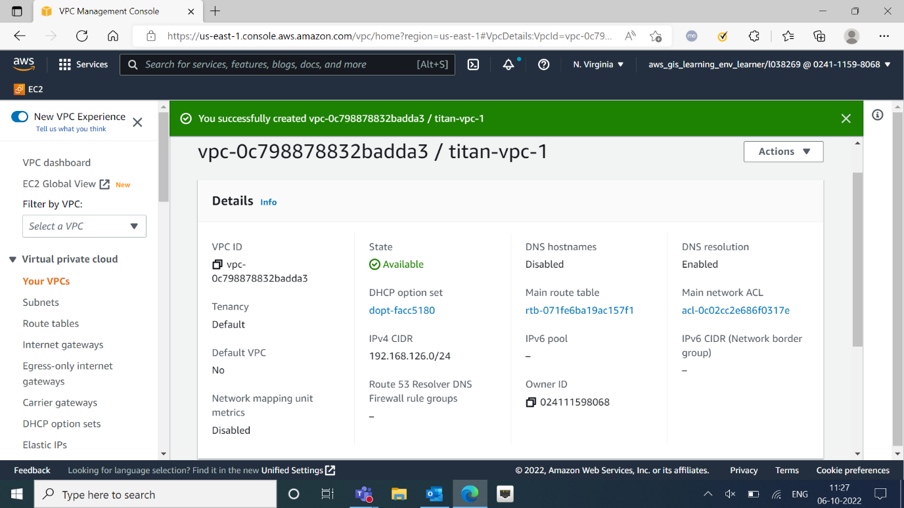**Creating VPC-1**

* Created VPC-1 with name “titan-vpc-1”
* IP address for VPC: 192.168.126.0

1. **Creating subnets**

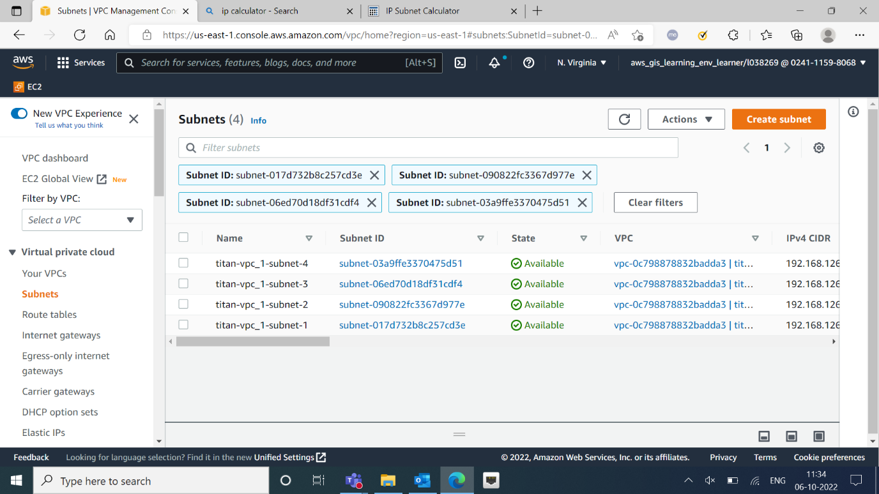

* Created 4 subnets connected to “titan-vpc-1”.
* 2 Public and 2 private subnets with ids below:

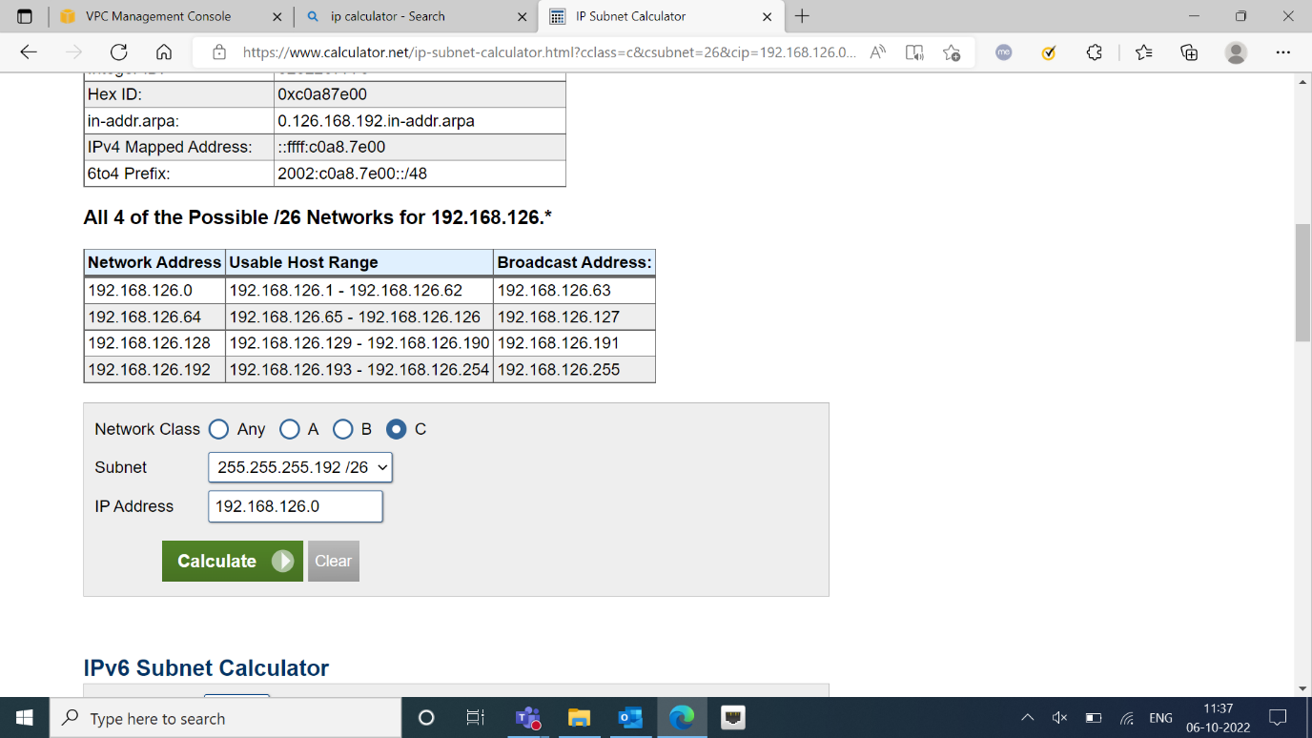

1. **Creating Internet Gateway**

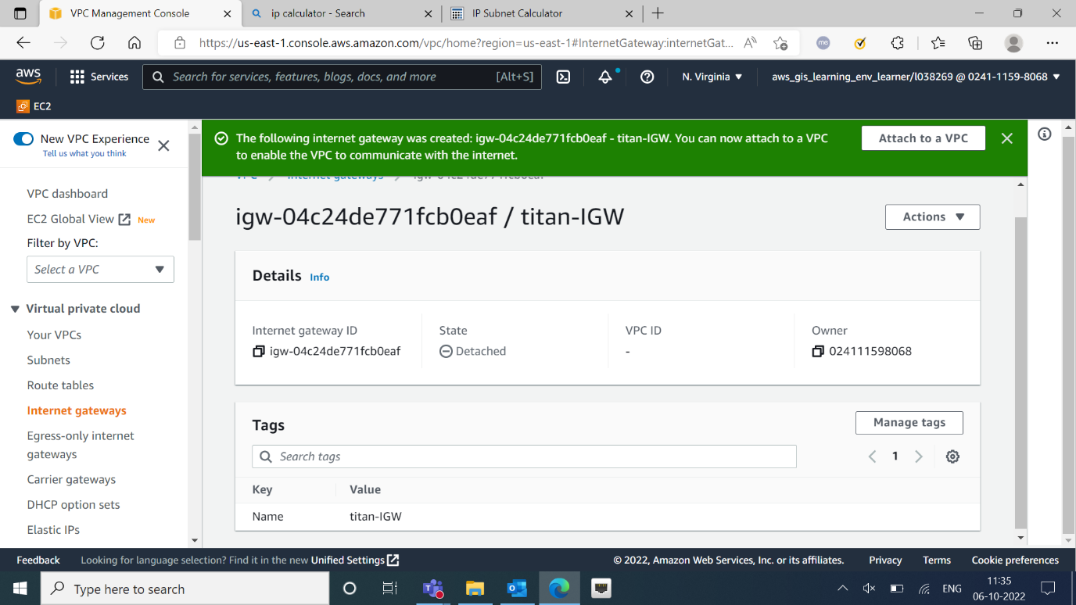

* Created Internet Gateway with name “titan-IGW”.
* Attached it to the created VPC “titan-vpc-1”.

1. **Creating Route Table**

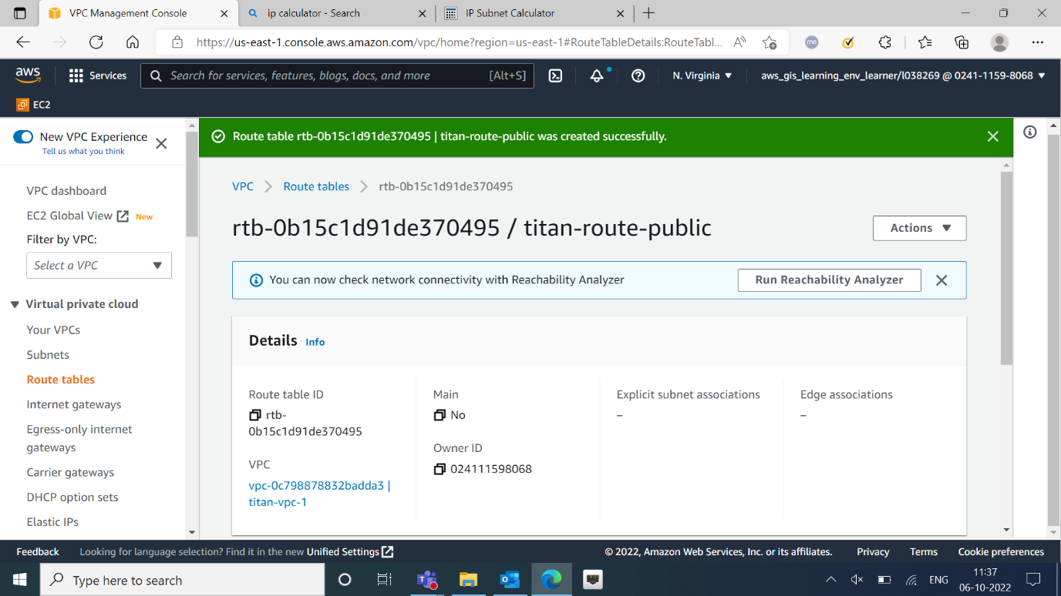

* Created Route table “titan-route-public”.
* Attached the routed table to the internet gateway “titan-IGW”.

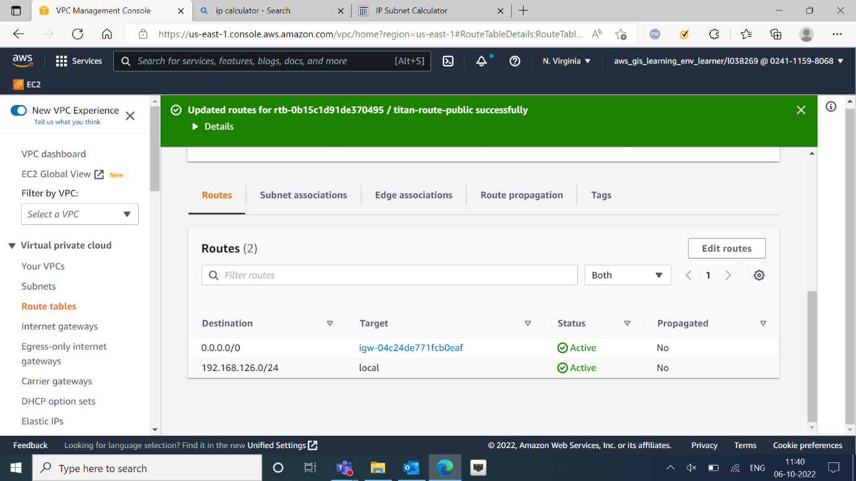

* Added subnet to the Internet Gateway.

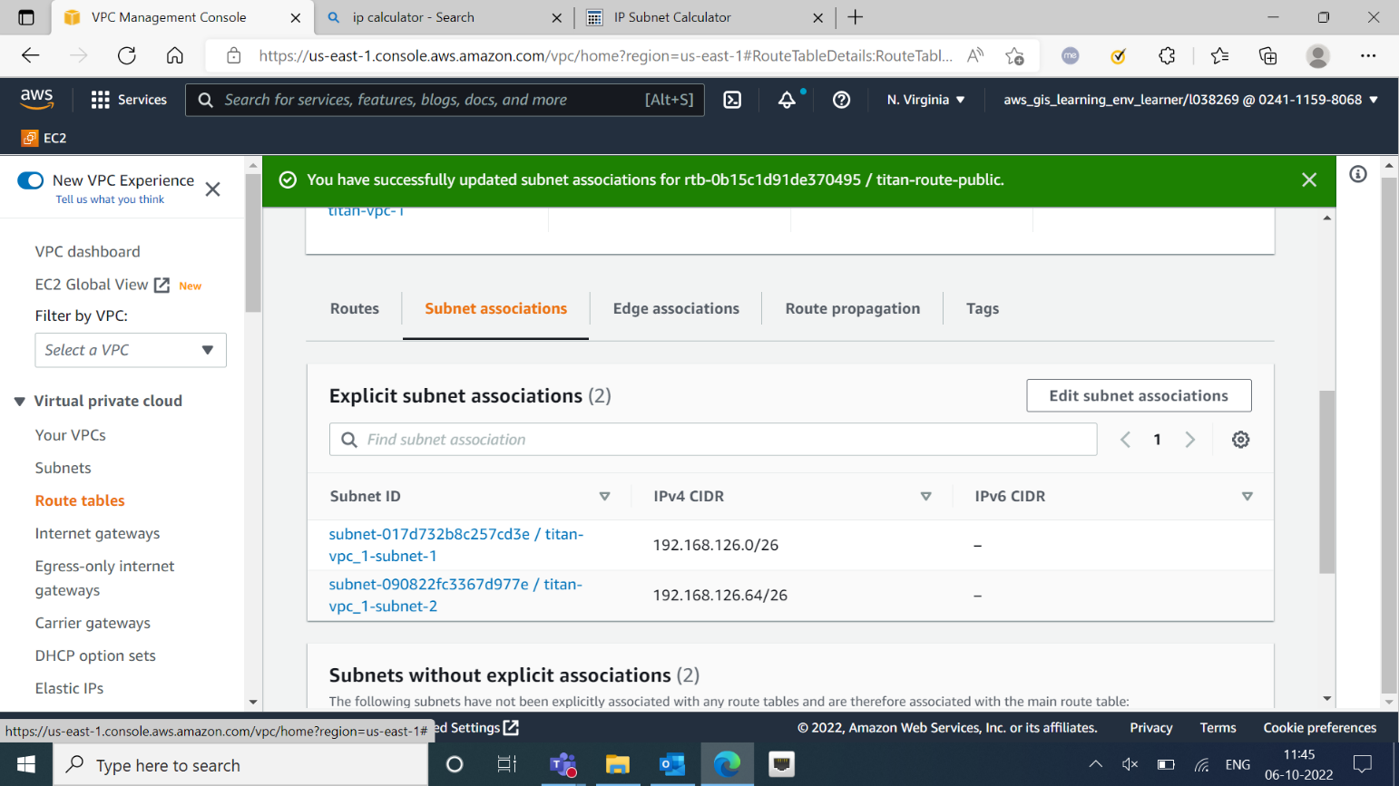

1. **Creating NAT Gateway**

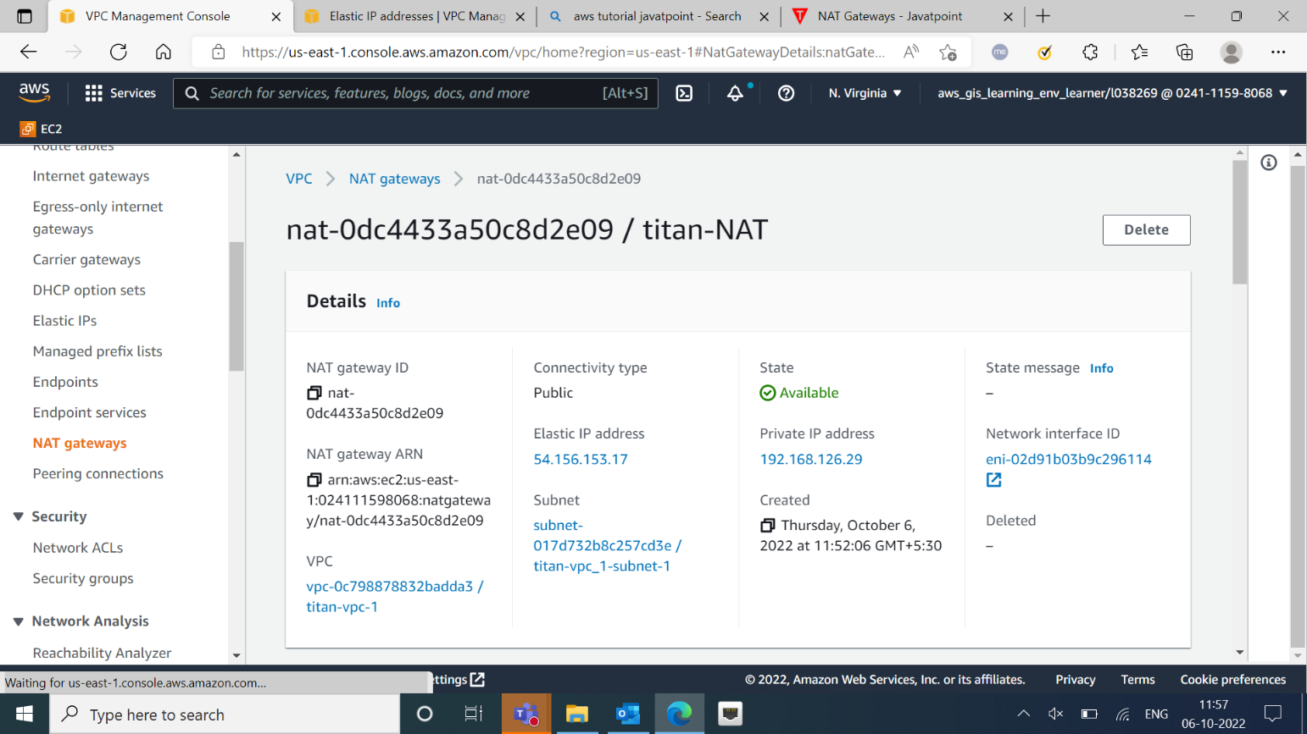

* Created NAT Gateway with name “titan-NAT”.

1. **Creating Private Route**

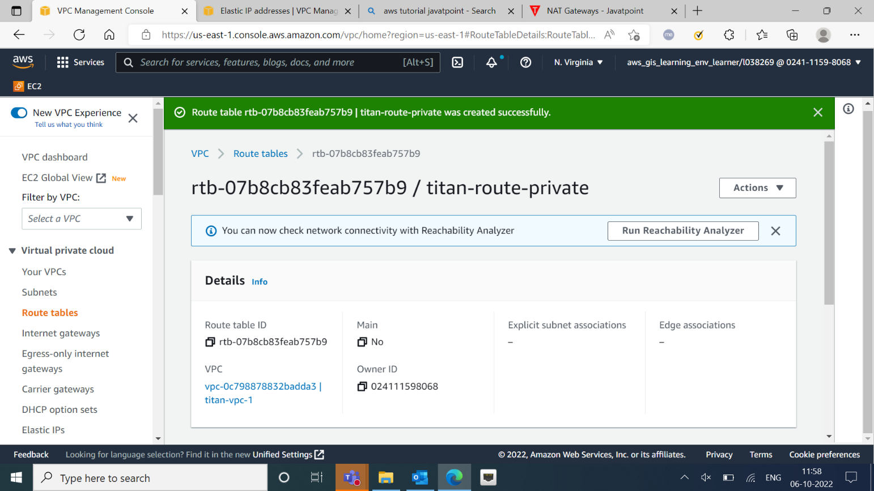

* Created Private route with name “titan-private-route”.
* Added subnet to private route.

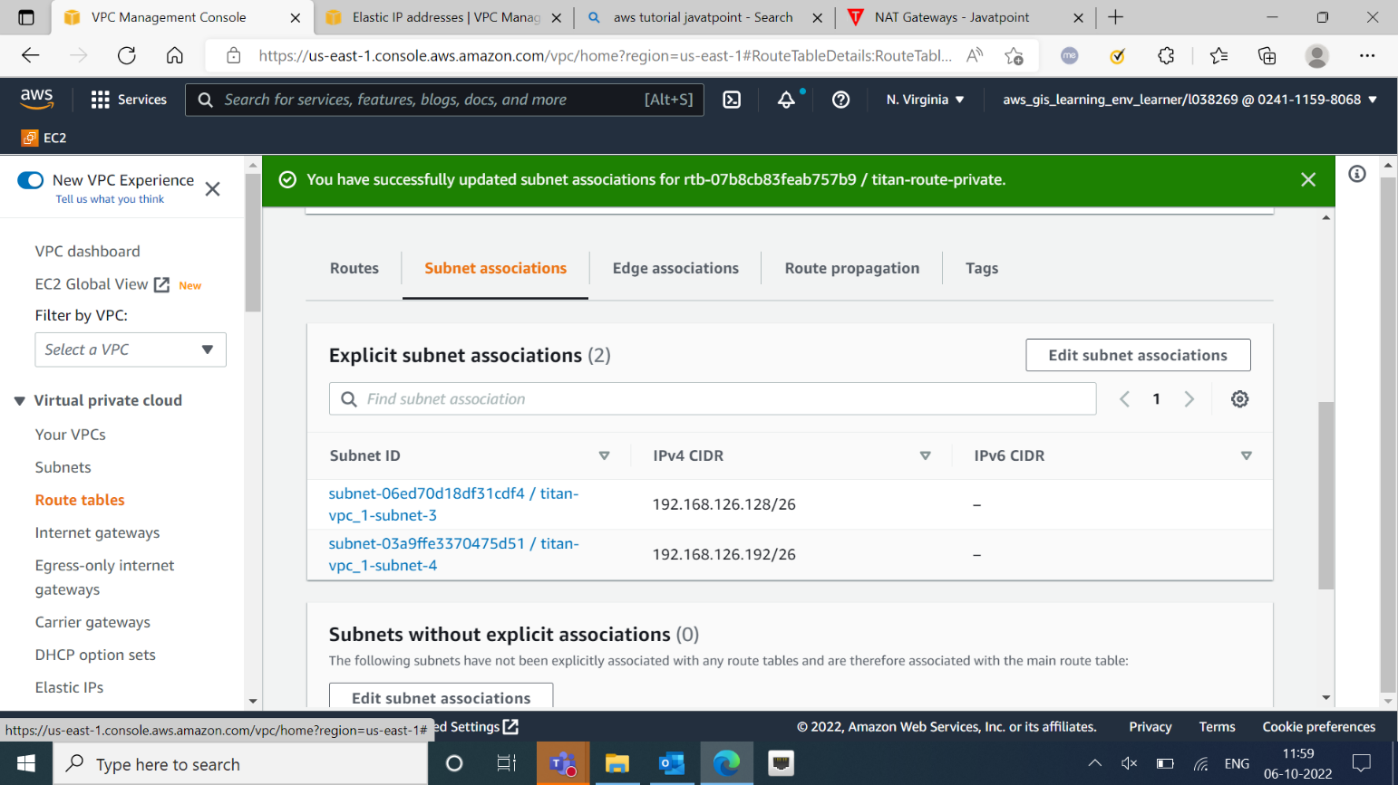

* Adding NAT Gateway to Private Route.

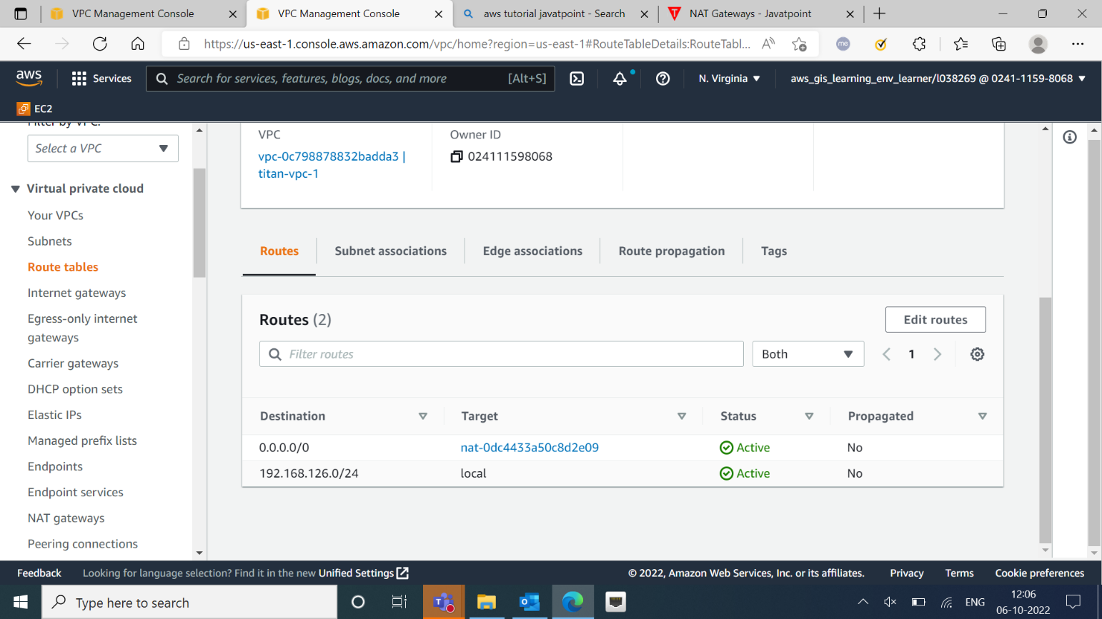

1. **Creating Security Group**

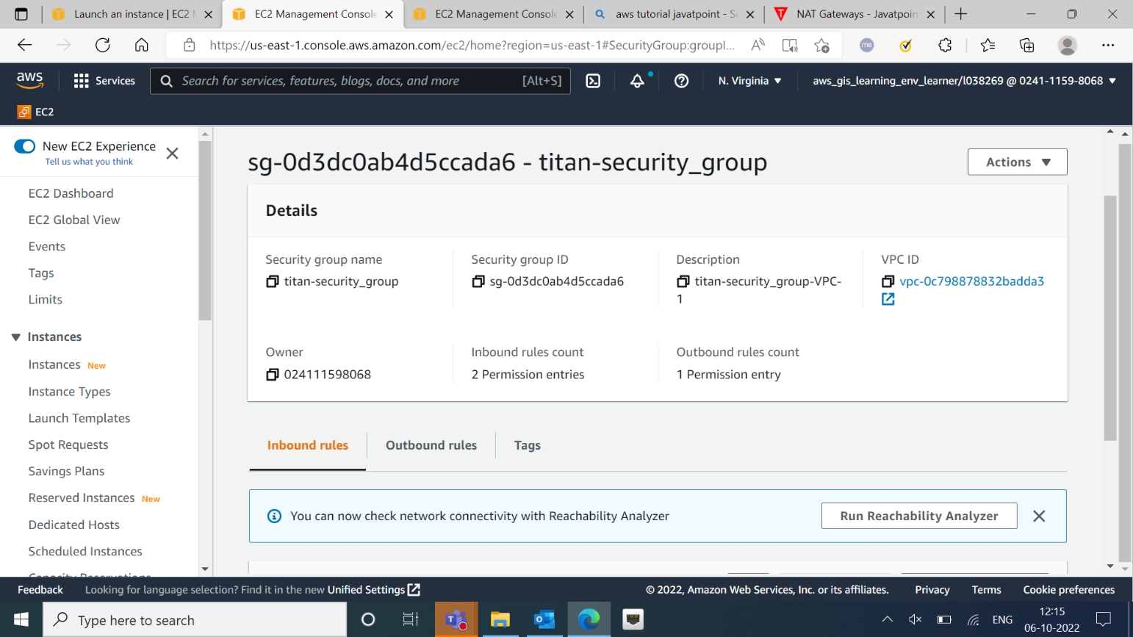

* Created security group “titan-security-group”.

1. **Creating Instances**

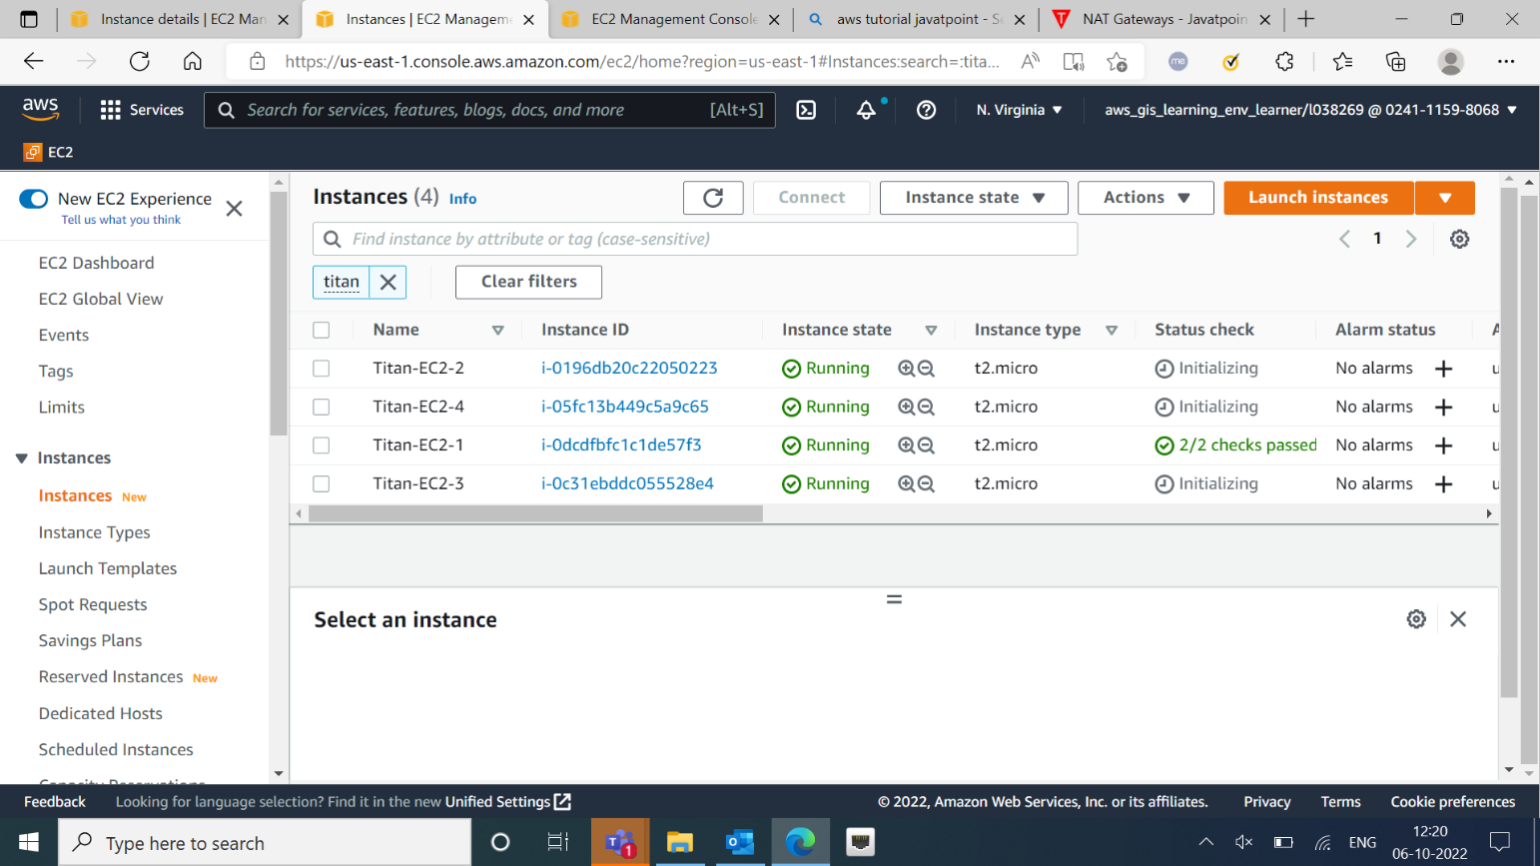

* Created 4 instances and connected them with respective subnets.

1. **Connecting to EC2**

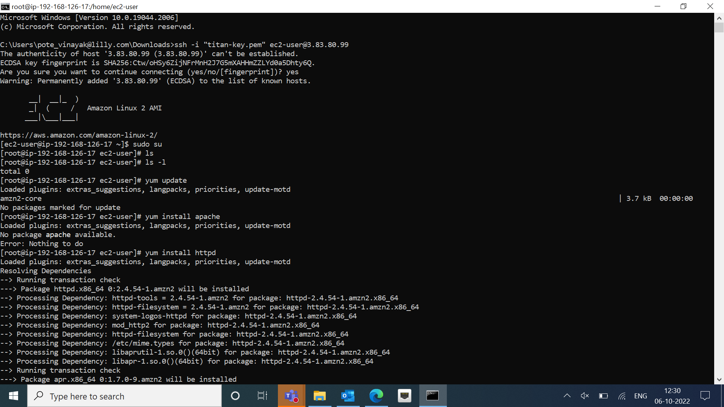

1. **Testing EC2**

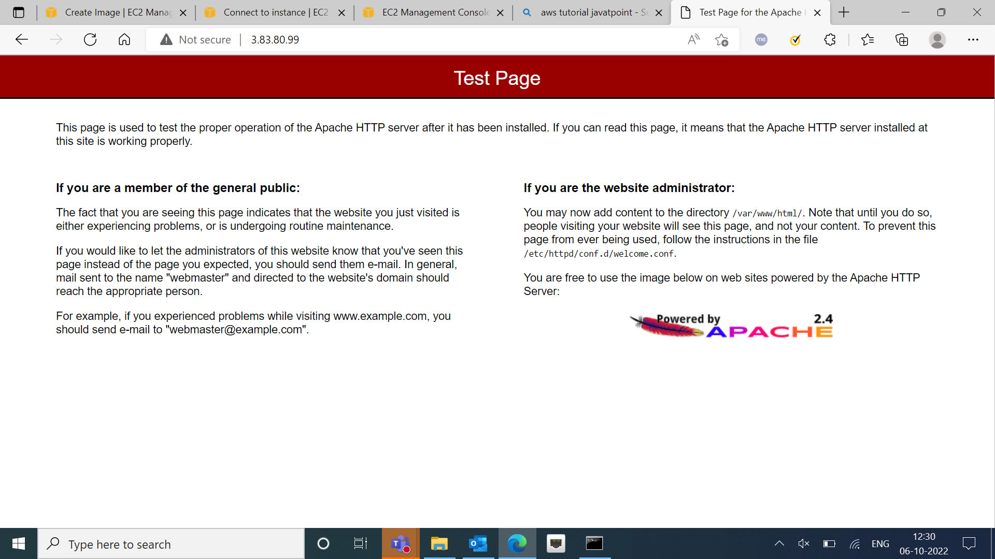

1. **Creating Image**

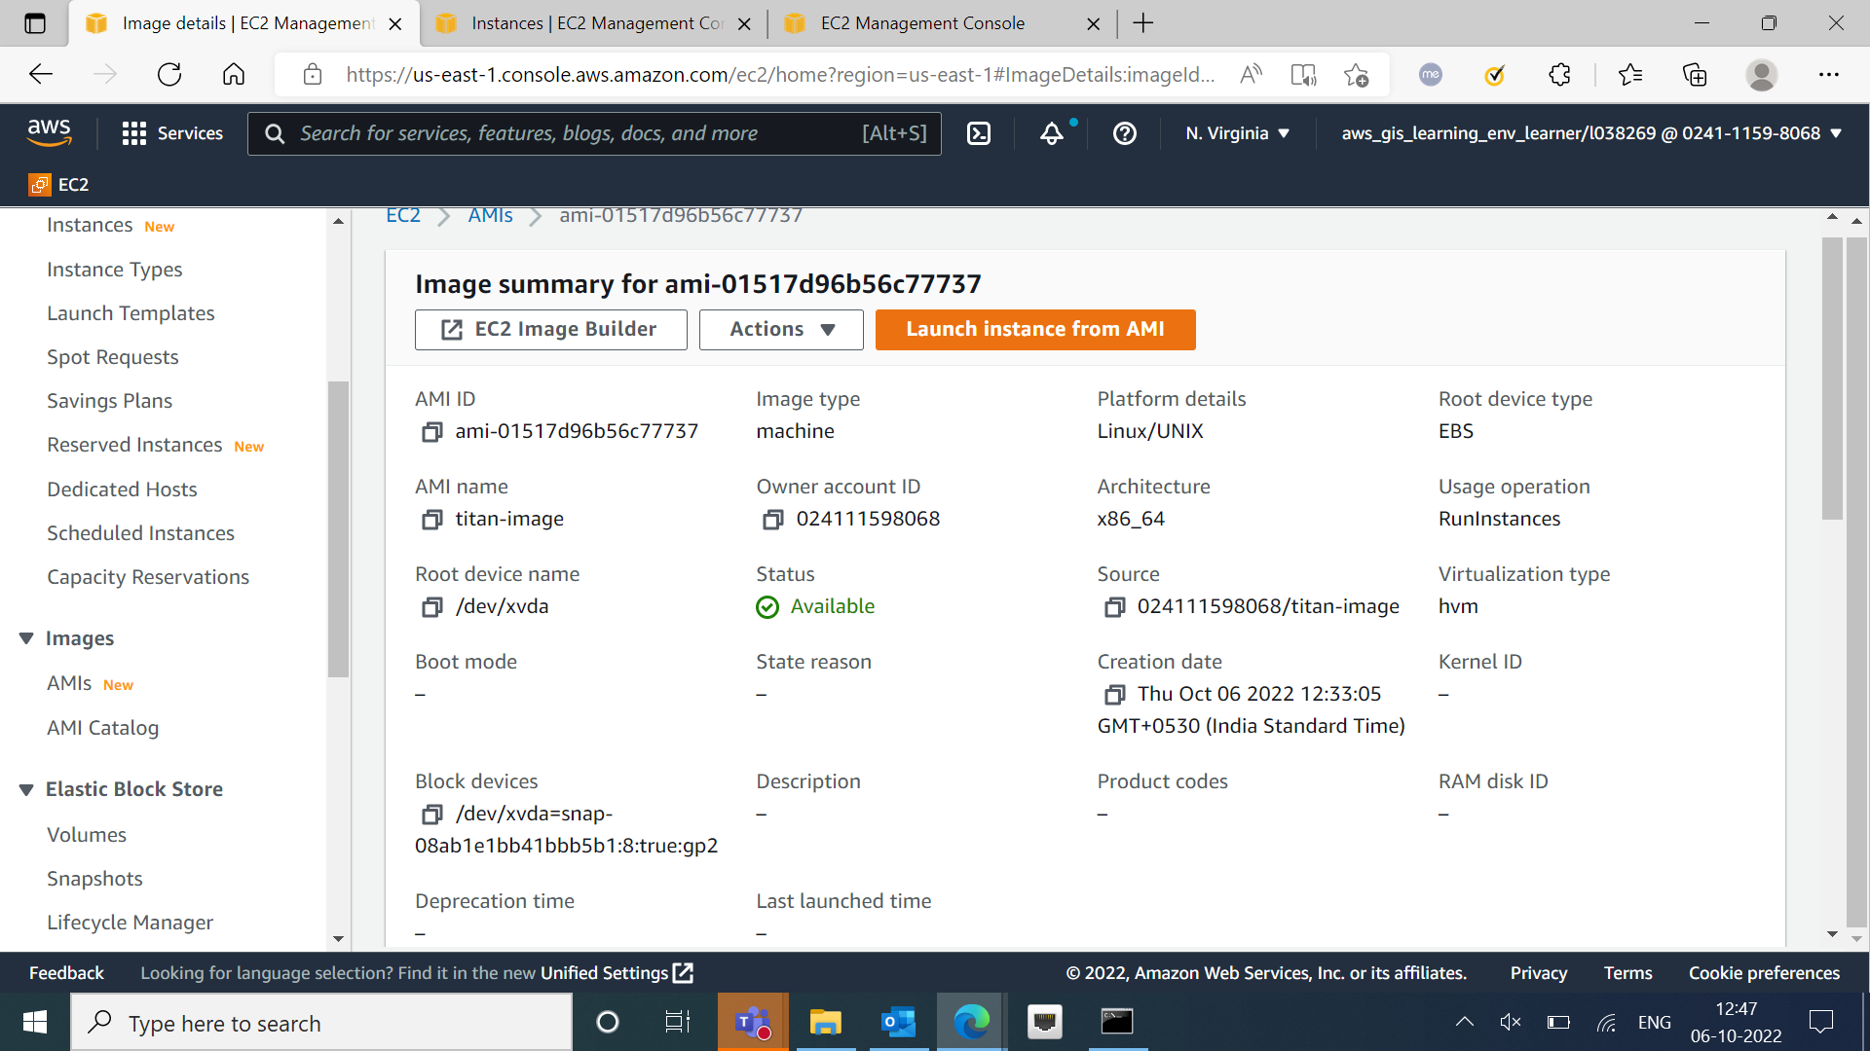

* Created Image

1. **Creating Template**

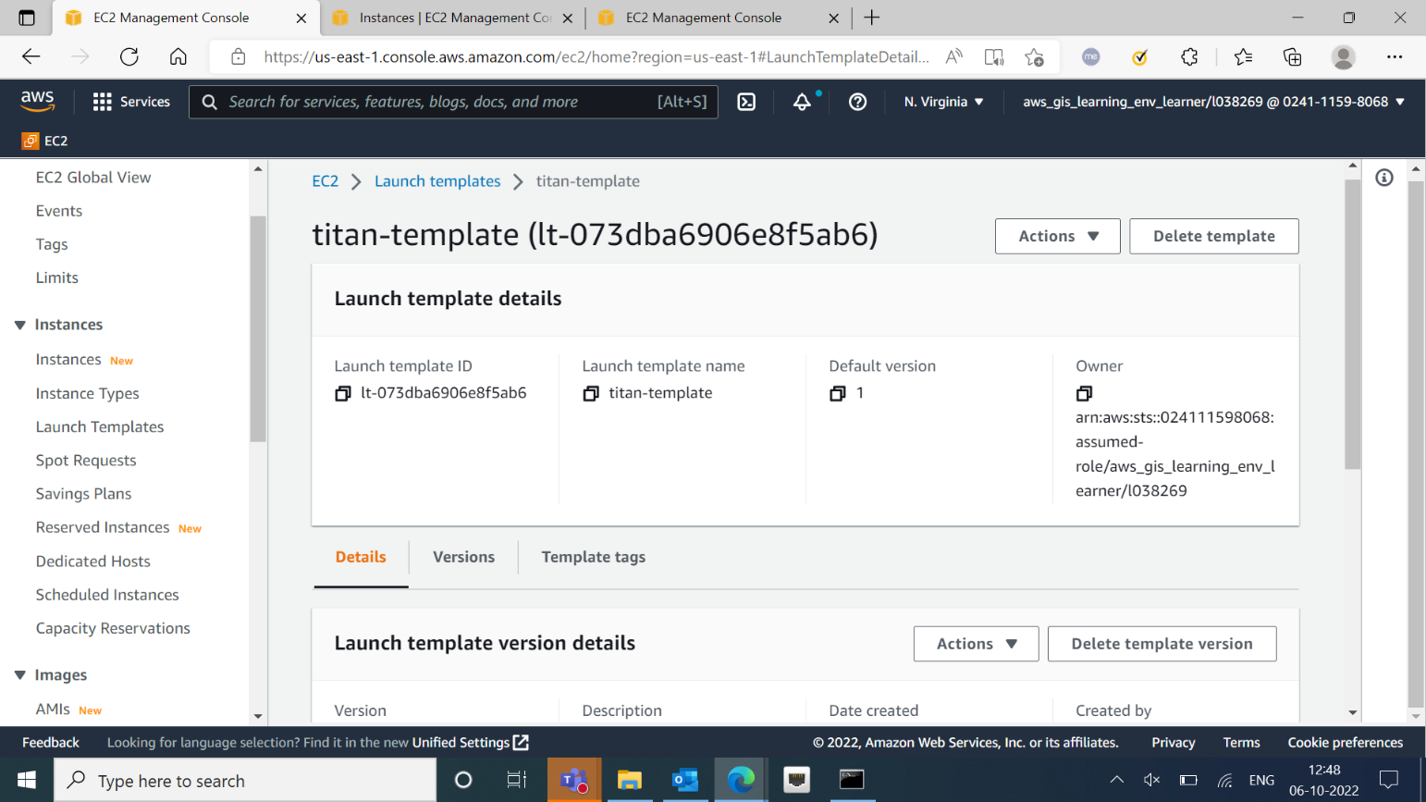

* Created Template with name “titan-template”.

1. **Creating Autoscaling Group**

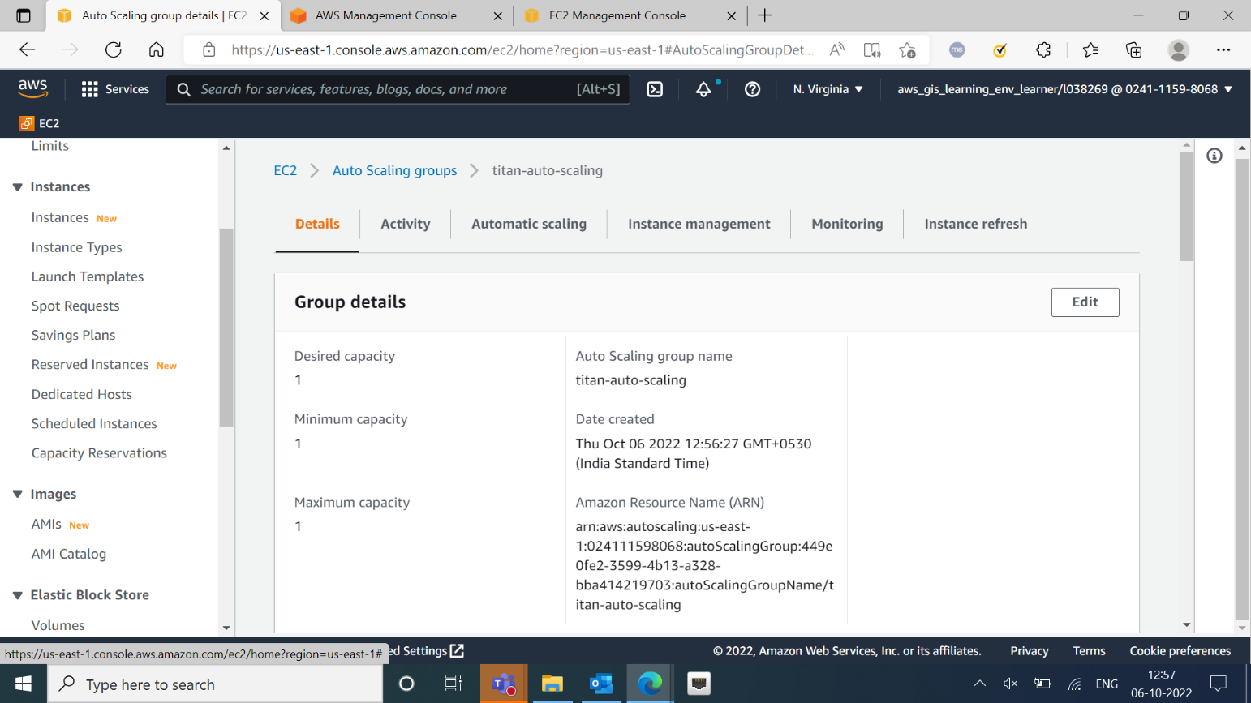

* Created autoscaling group “titan-auto-scaling”.
* Details of the auto-scaling group.

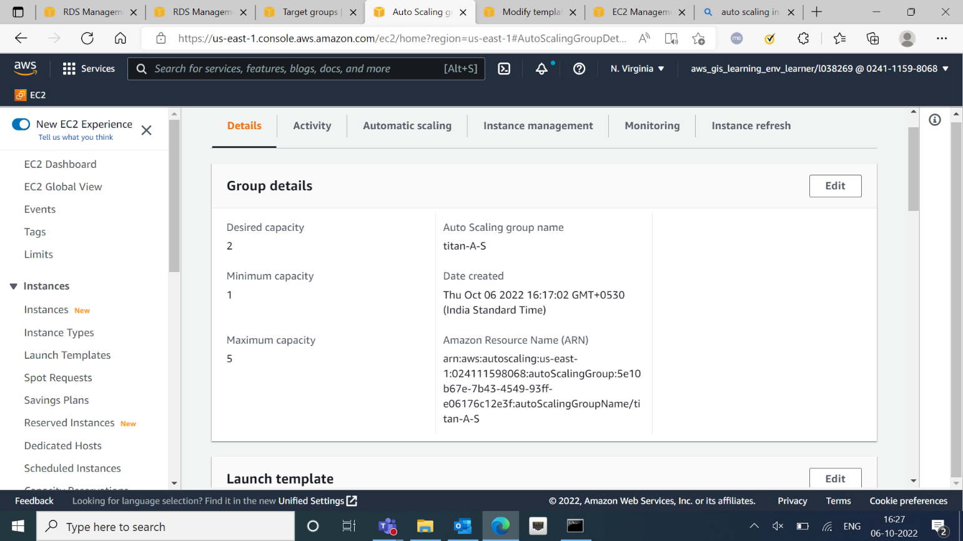

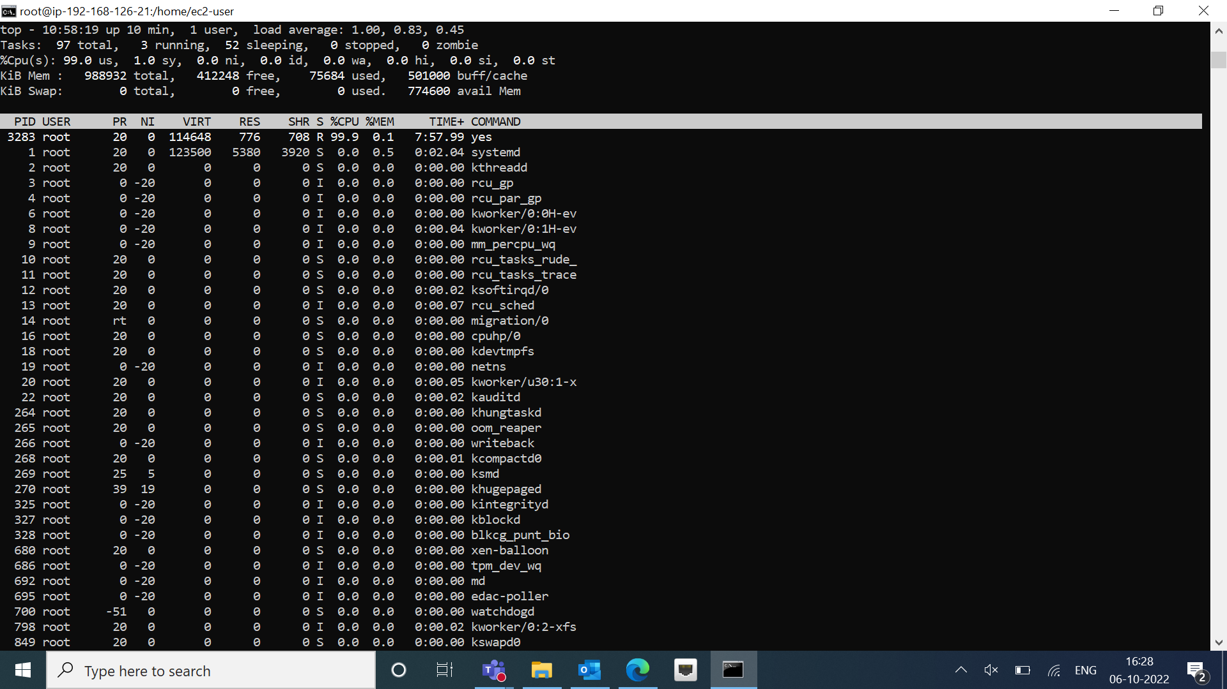

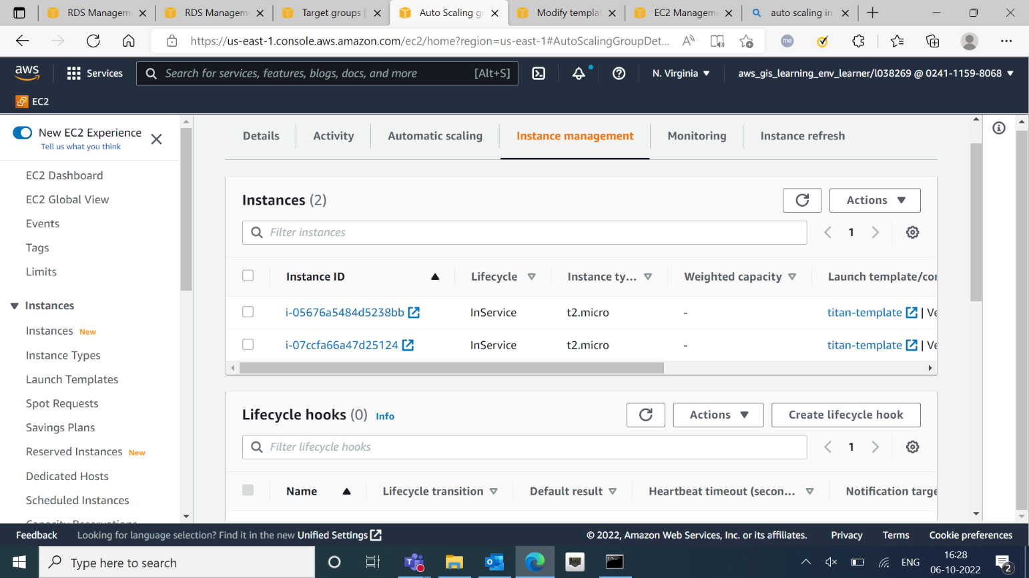

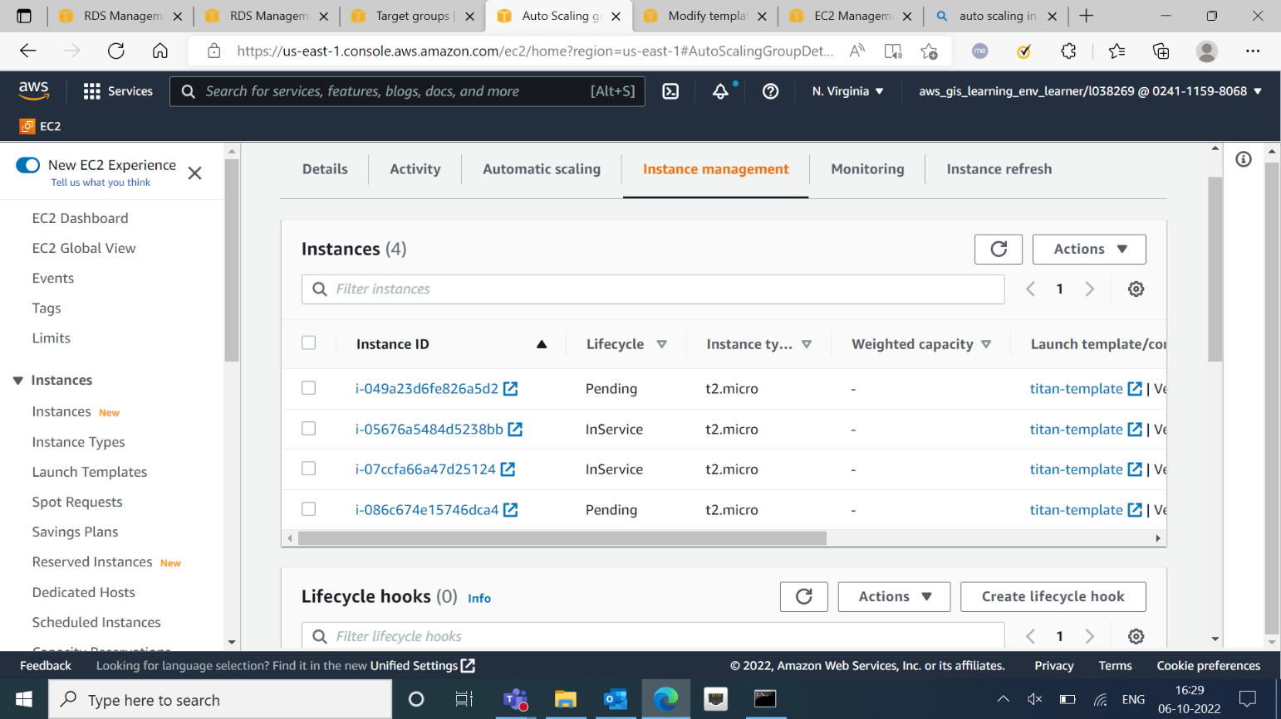

1. **Creating RDS**

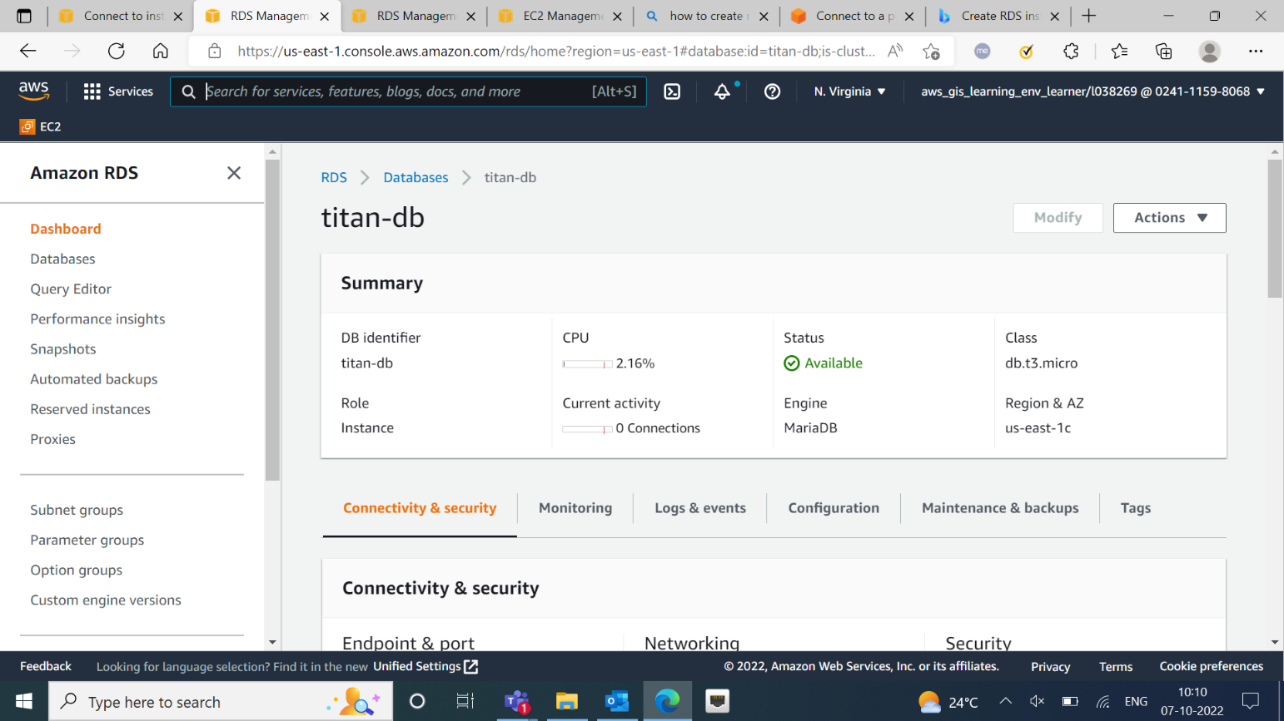

* Created RDS database “titan-db”.
* Connected RDS to a private instance.

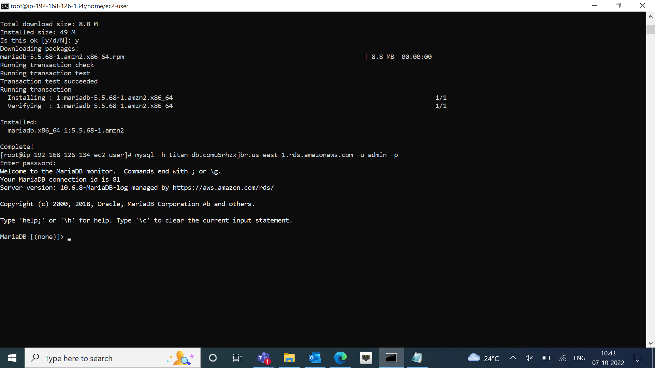

1. **Creating S3 bucket**

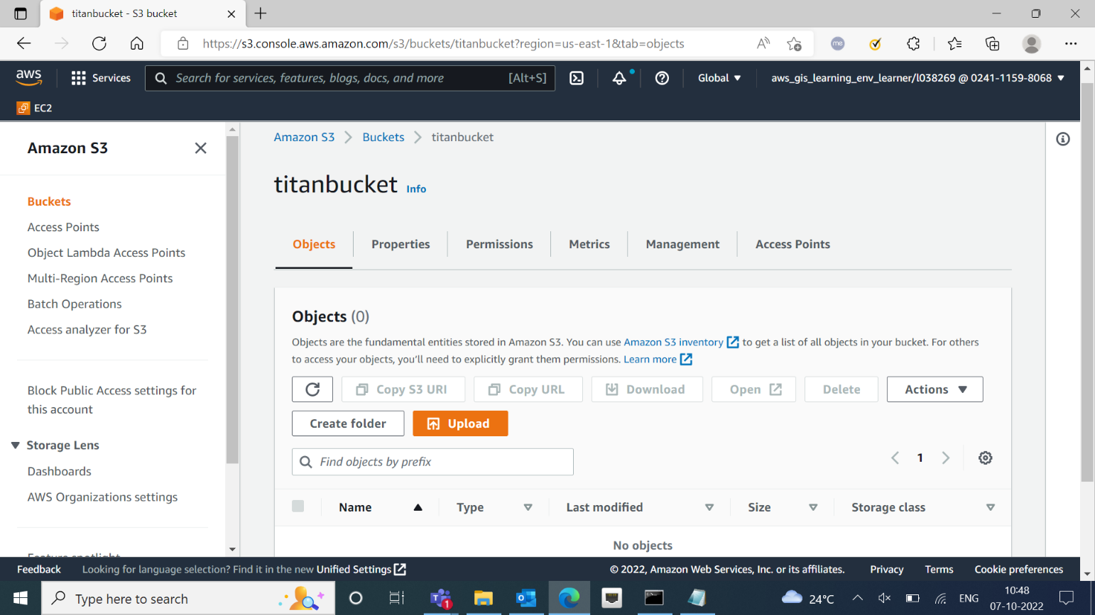

* Created S3 bucket with name “titanbucket”.

1. **Creating DynamoDB table**

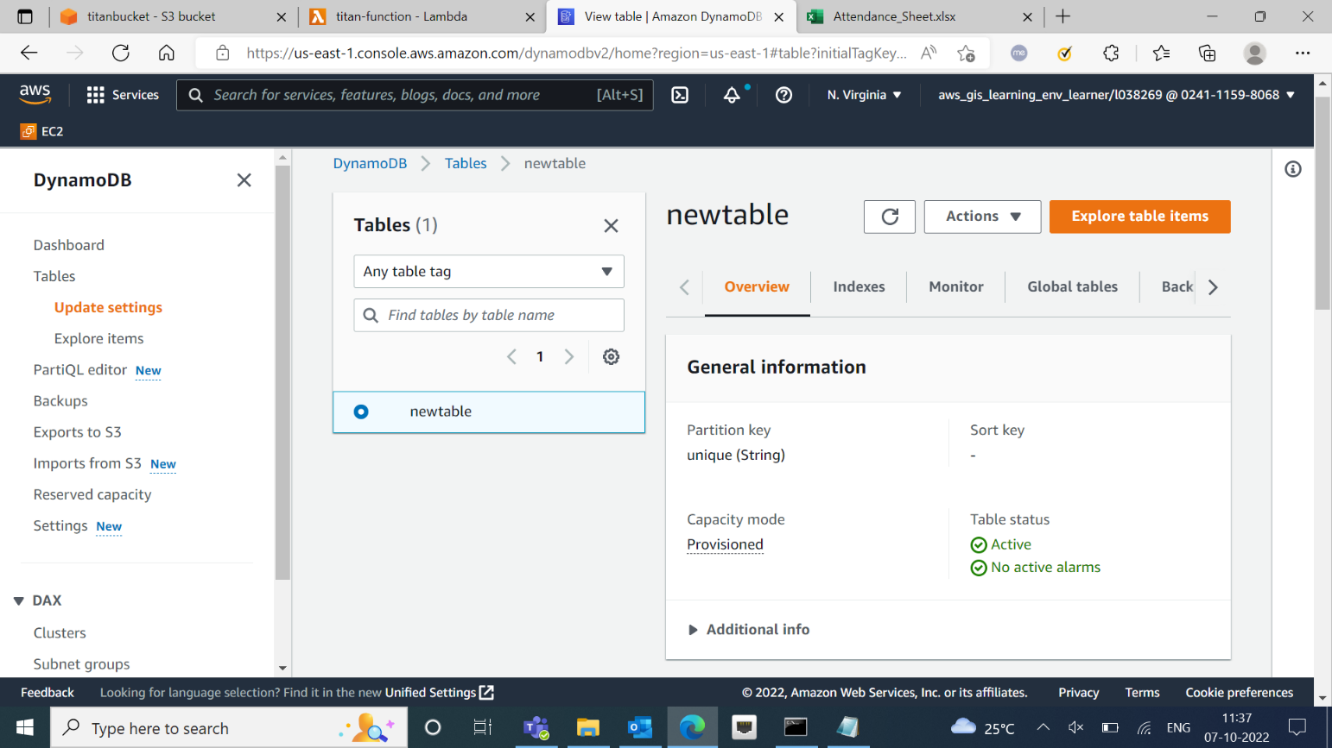

1. **Uploading data in DynamoDB**

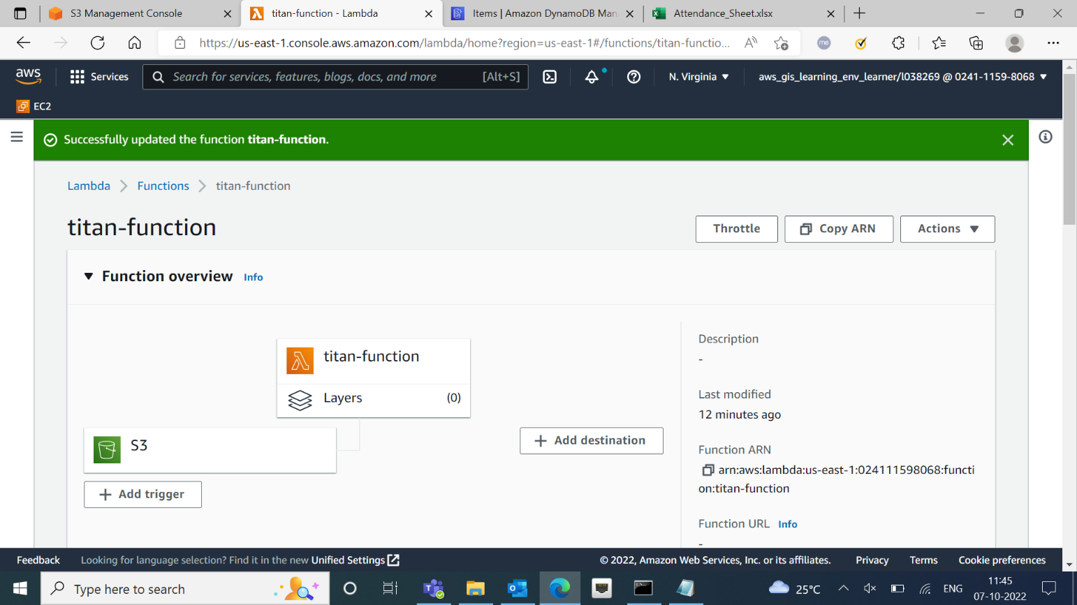

* Added code to the lambda function.
* Uploaded data in the table.

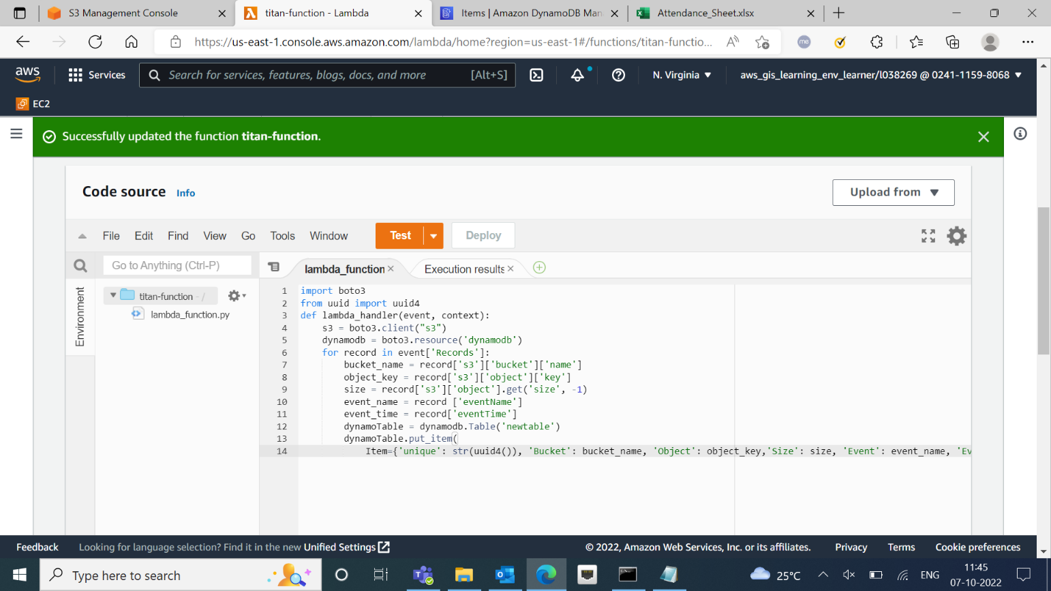

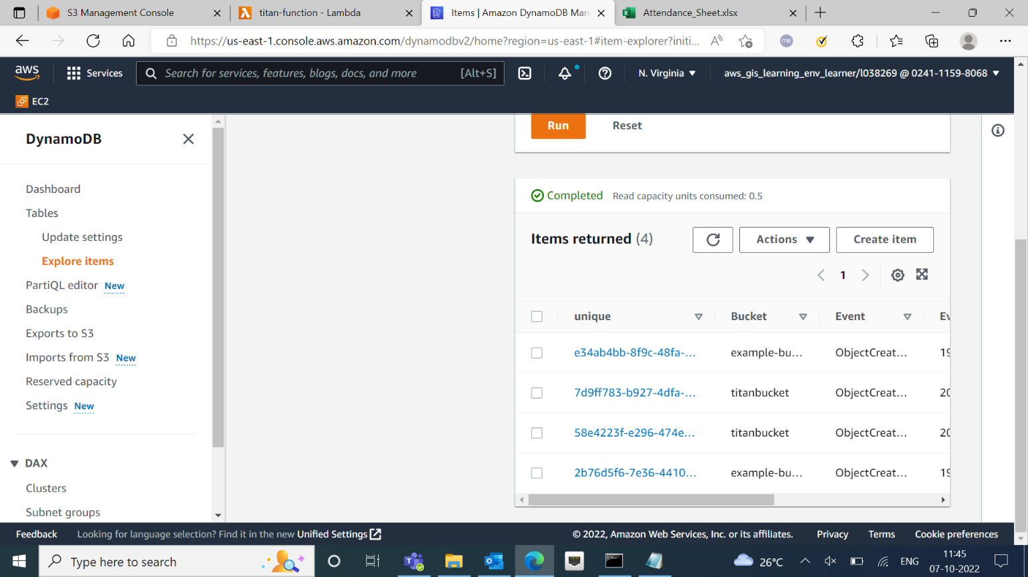

1. **Creating role for S3**

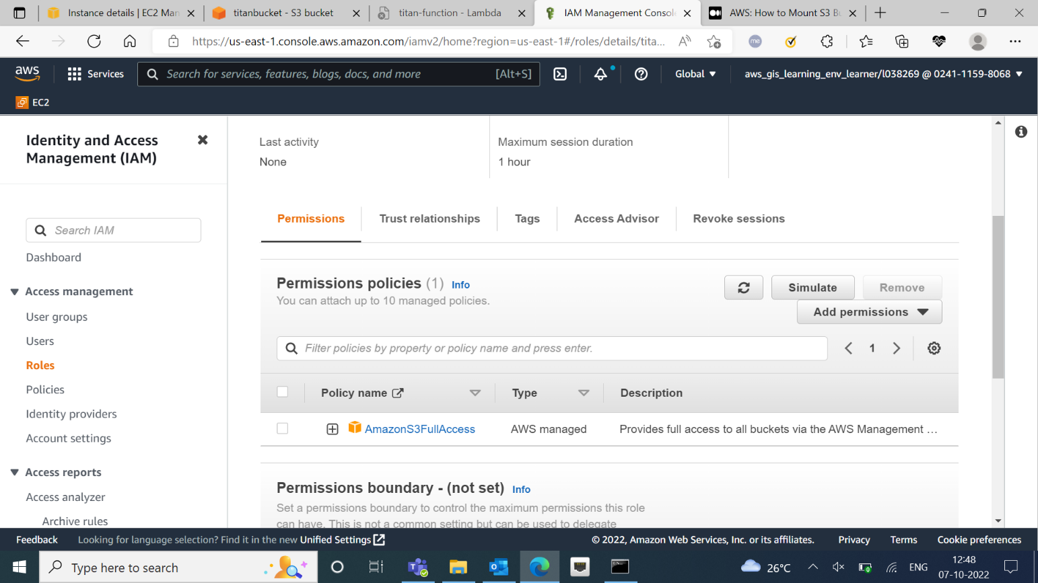

* Created role for the S3 bucket with the access policy.

1. **Mounting S3 bucket on EC2 instance**

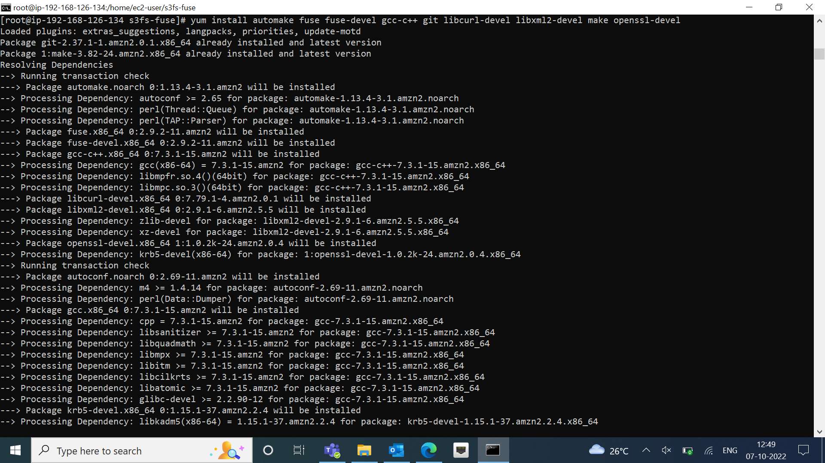

* Mounted the created S3 bucket on the EC2 instance.

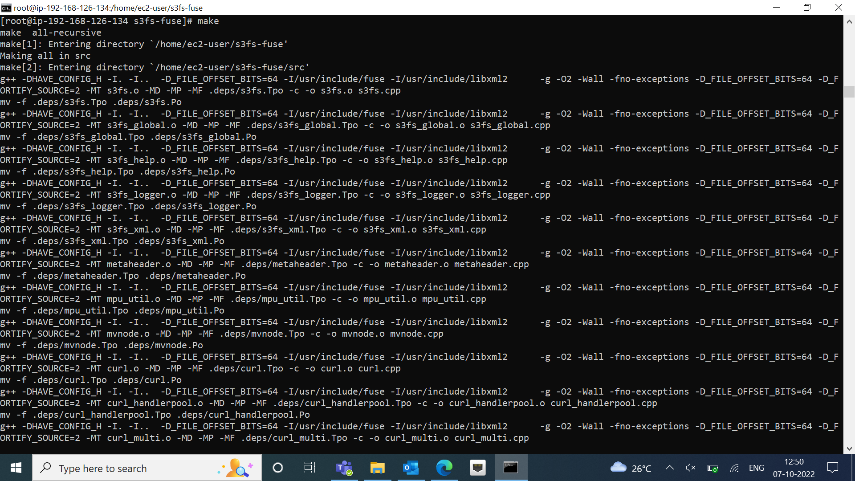

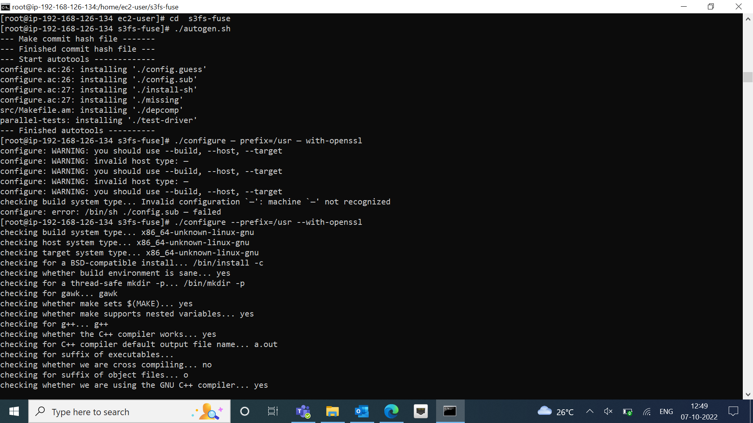

1. **Output**

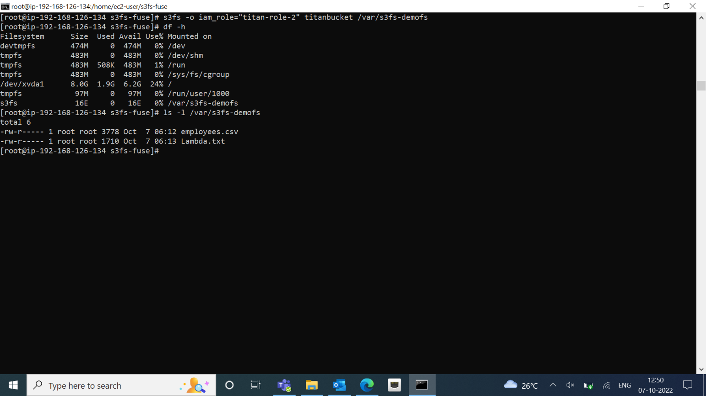

* Final output showing the name of the files :

1. Employees.csv
2. Lambda.txt

**Part 2: A. Connecting S3 to Athena using glue**

1. **Creating buckets**

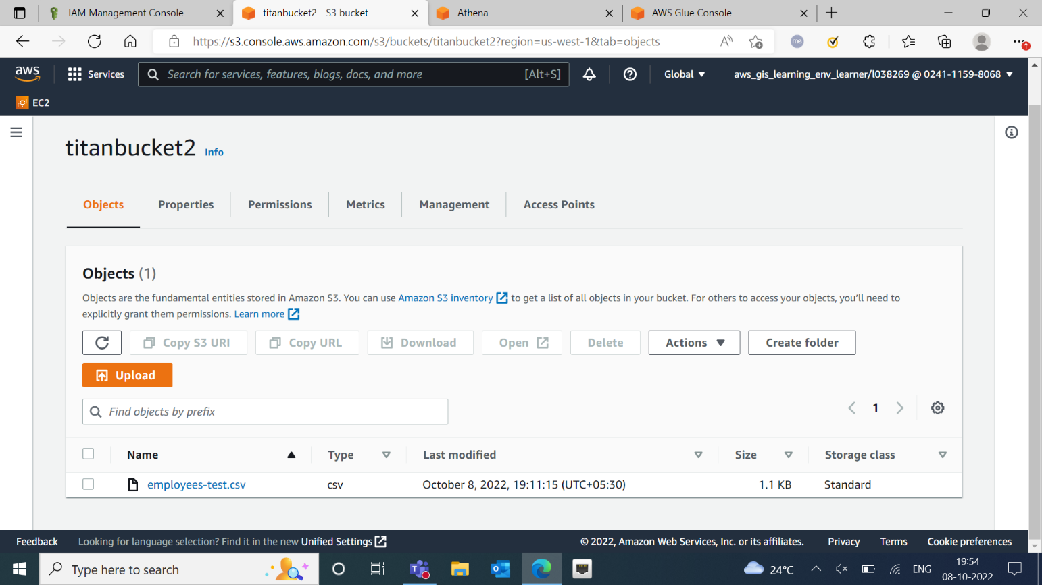

* Created a bucket with csv.

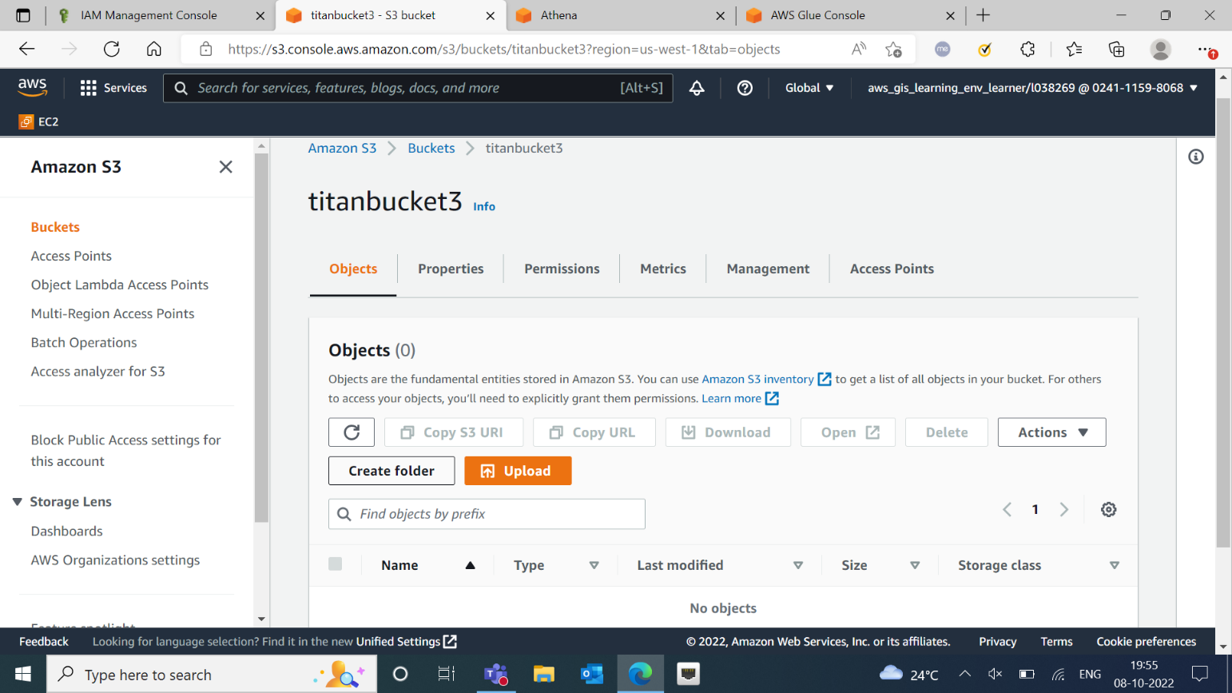

* Created second bucket to store output.

1. **Creating a Crawler**

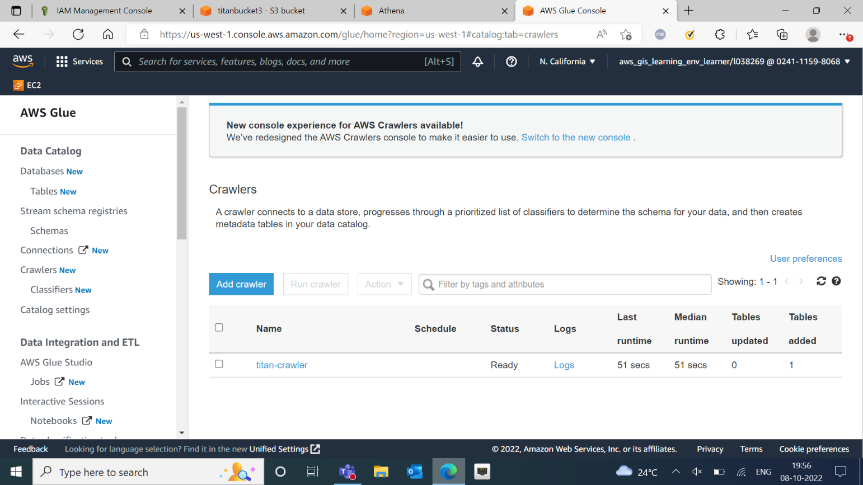

* Created a crawler named “titan-crawler”.

1. **Creating workgroup in Athena**

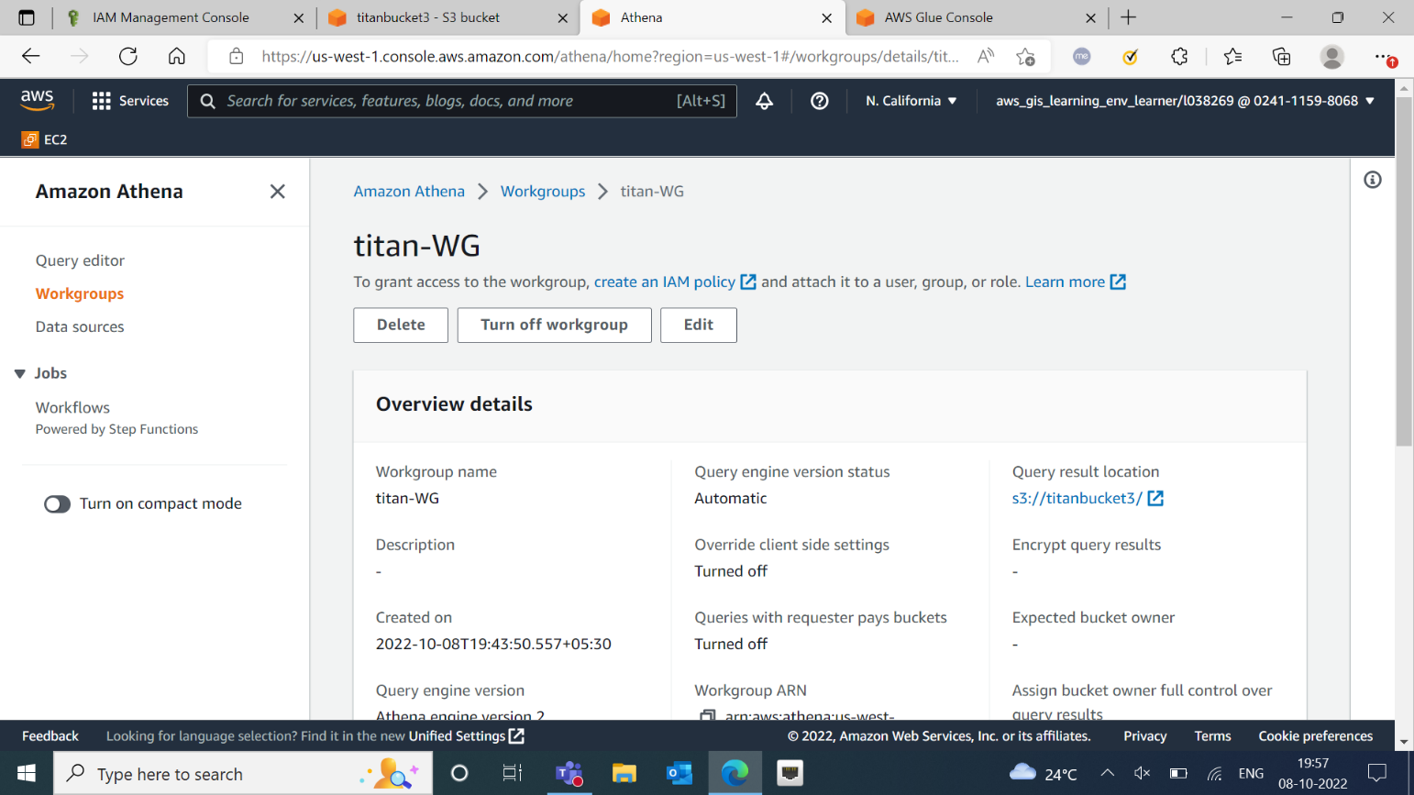

* Created a workgroup in Athena with name “titan-WG”.

1. **Selecting Database and running Query**

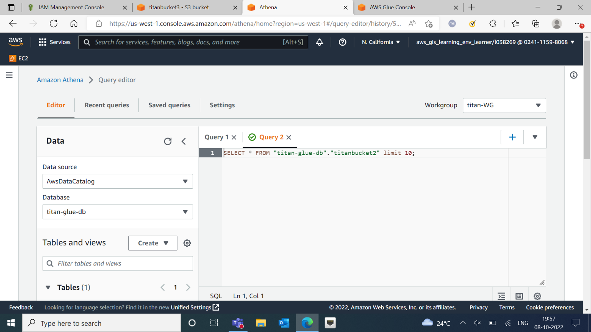

* Selected database “titan-glue-db” from “titanbucket2” and ran the query.

1. **Output**

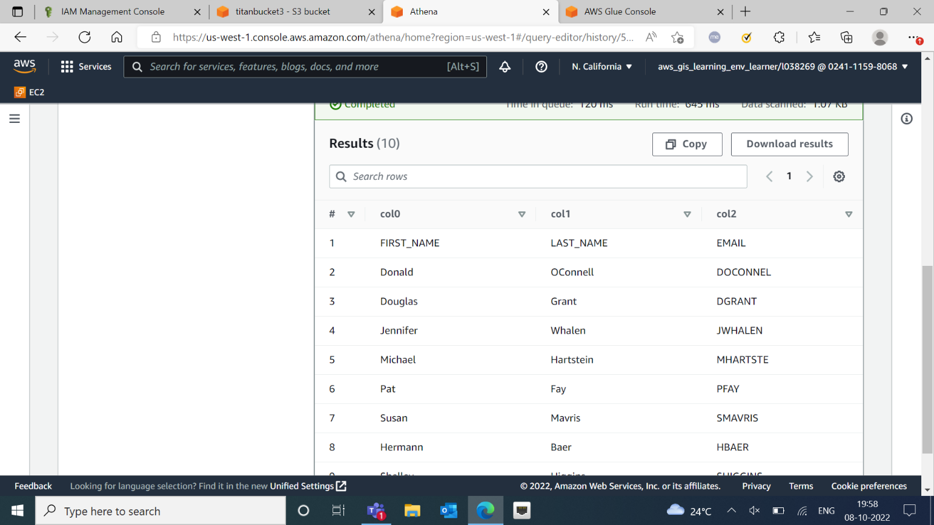

* Result showing entries in the selected database.

**Part 2: B. Connecting S3 to Redshift using Glue**

1. **Creating VPC Peering**

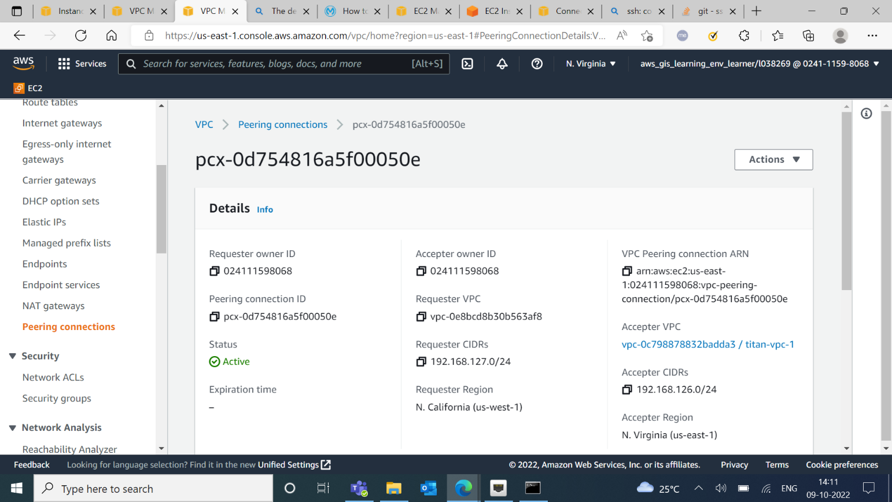

* Established a peering connection.

1. **Creating EFS**

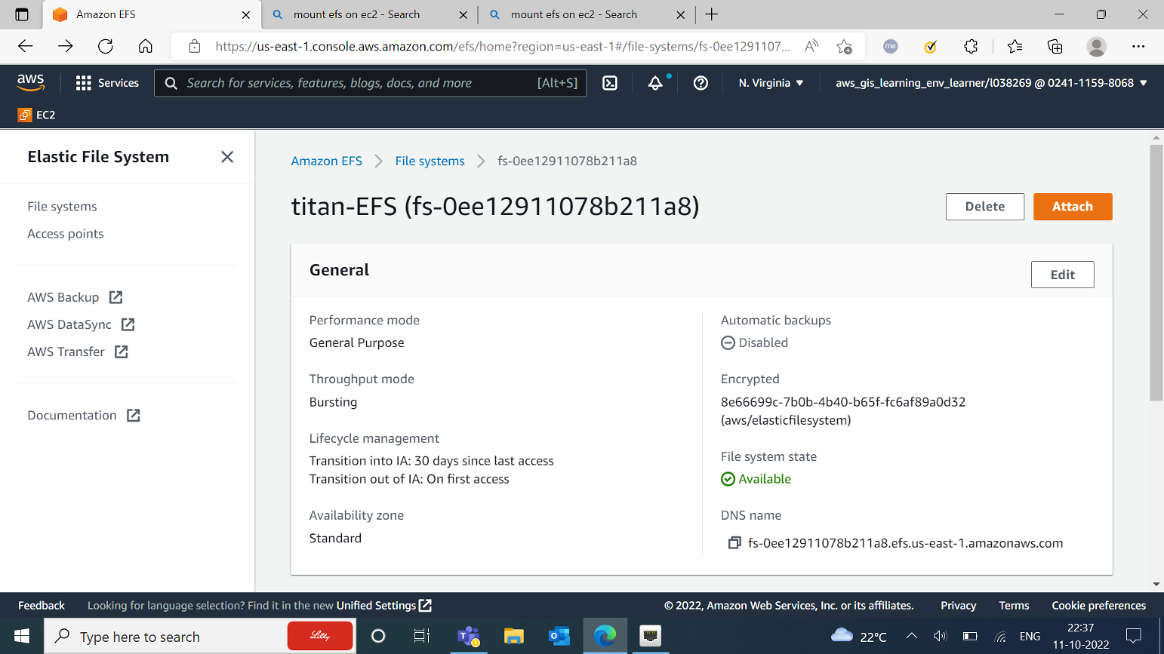

* Created EFS with name “titan-EFS”.
* Accessing Private EC2 using Public EC2.

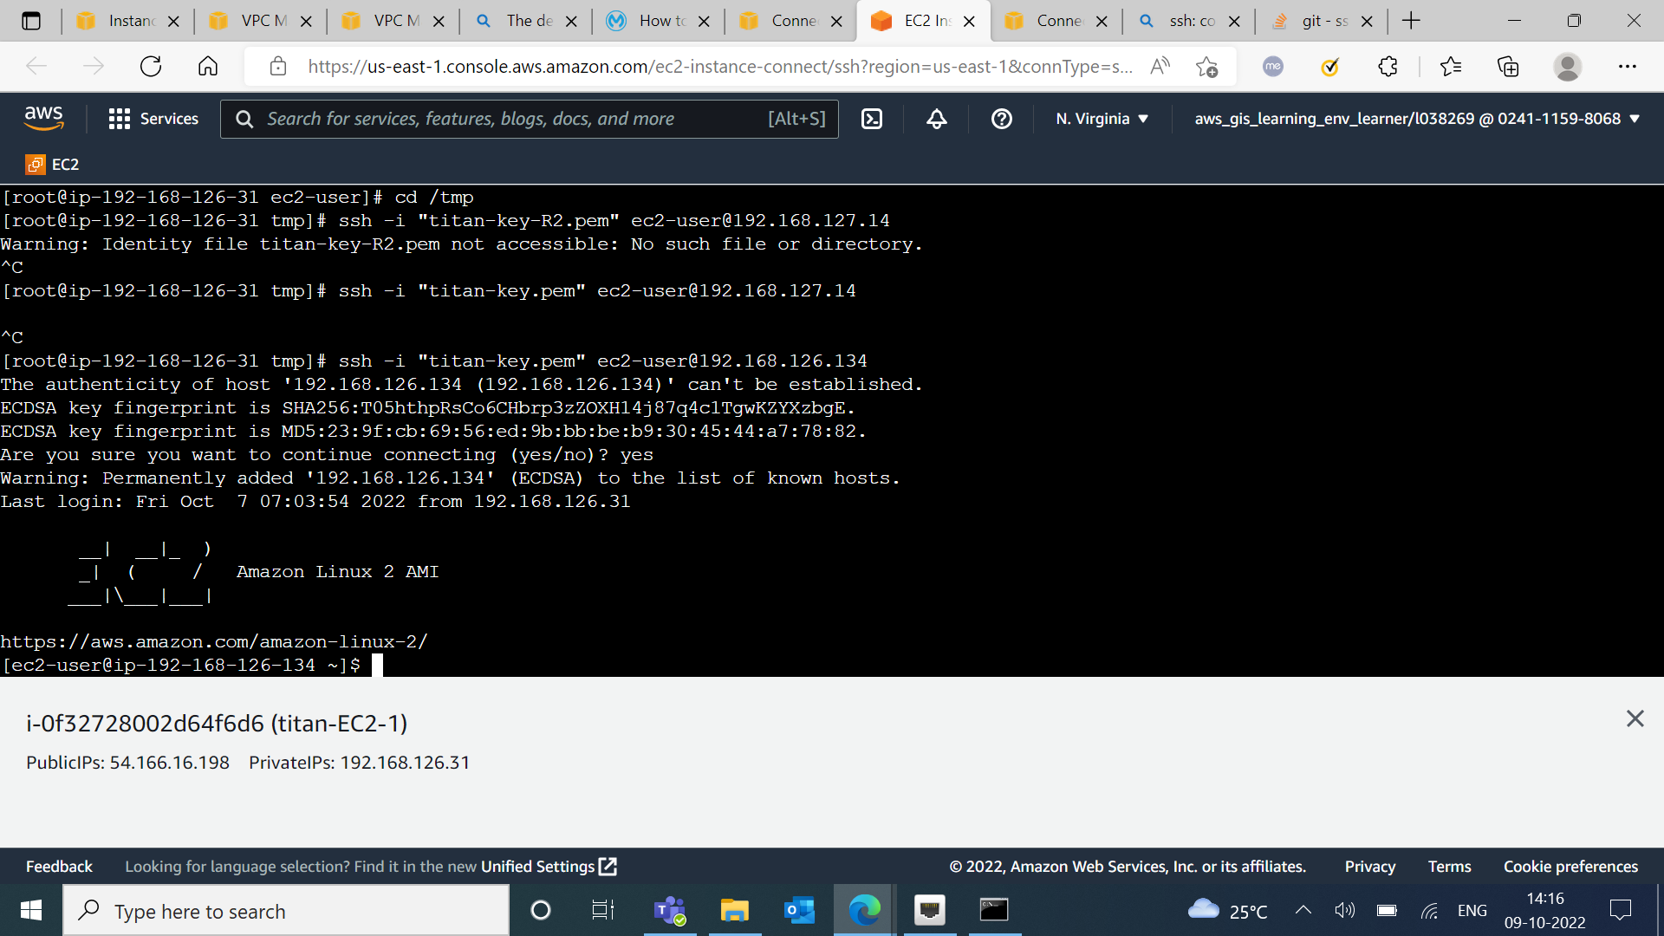

* Installing amazon-efs-utils.

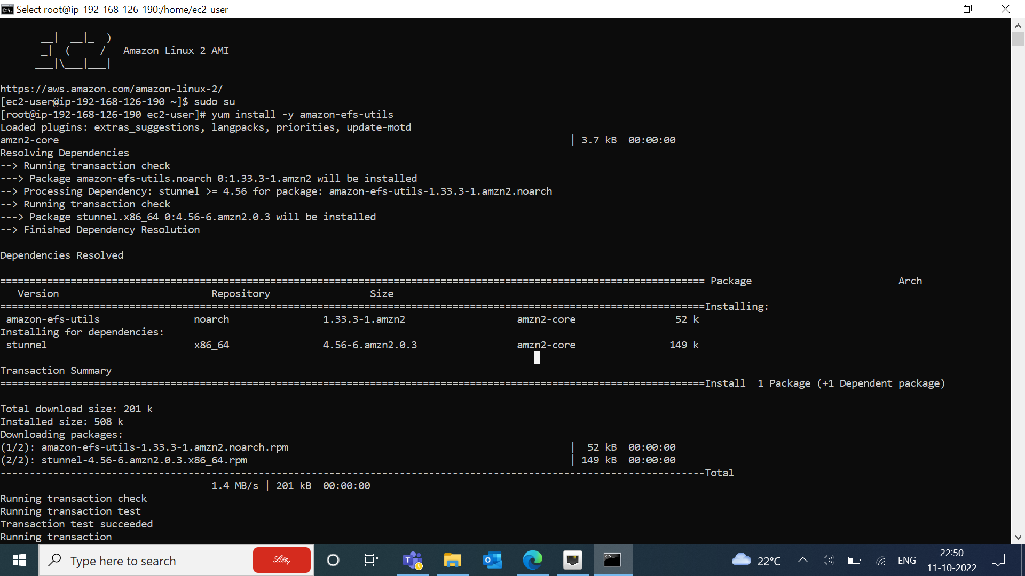

1. **Mounting EFS on instances**

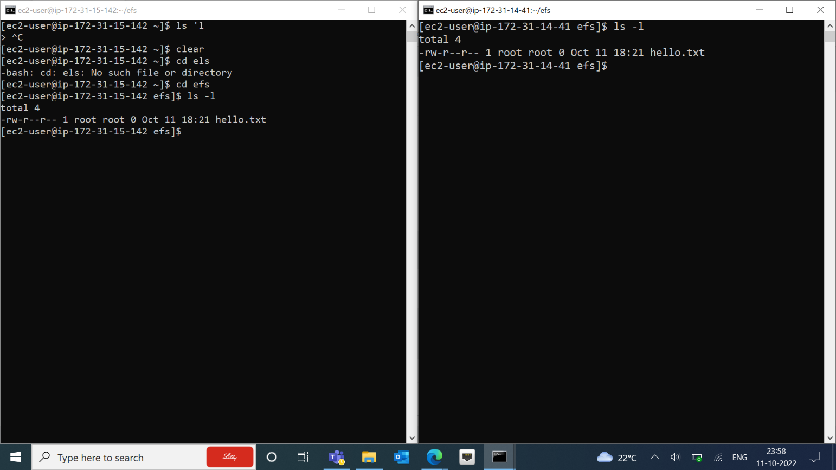

* After mounting EFS on 2 instances, we accessed same file on both the instances.

1. **Creating S3 bucket with dataset**

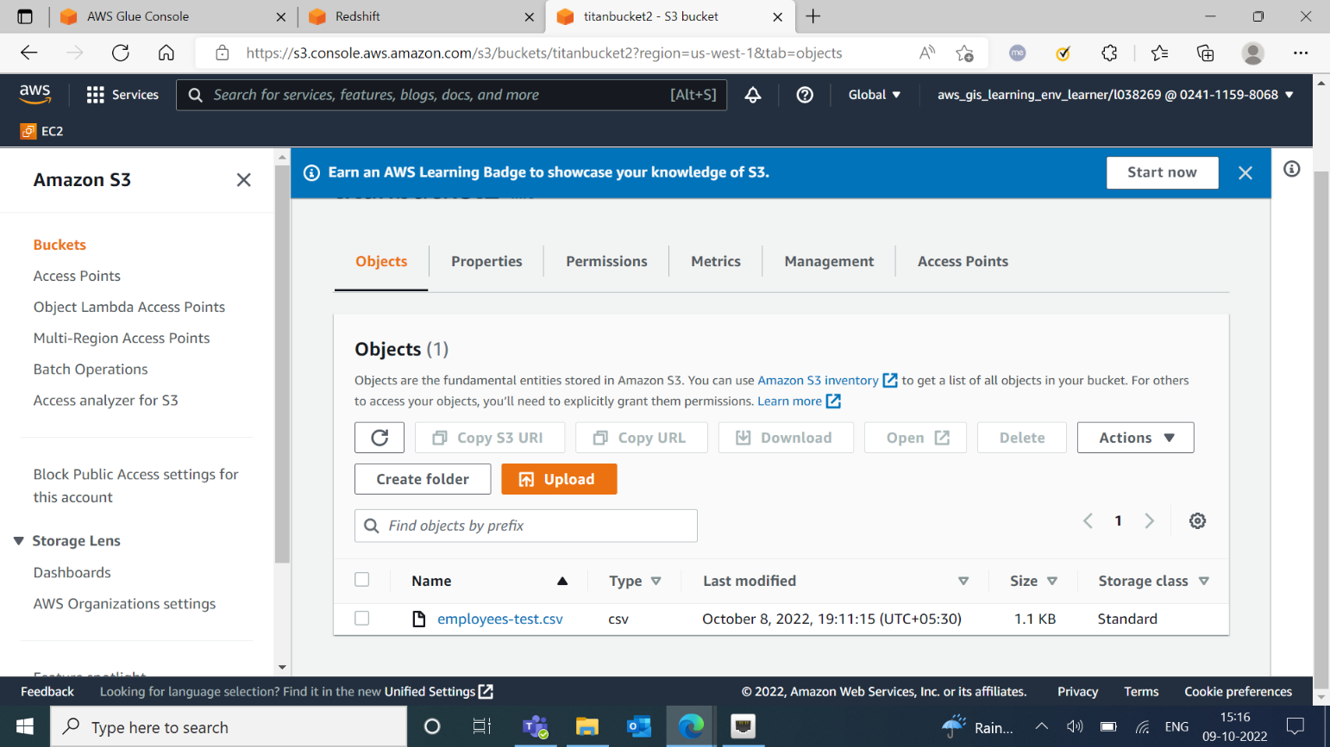

* Created a S3 bucket with dataset “employees-test.csv”.

1. **Creating Redshift cluster**

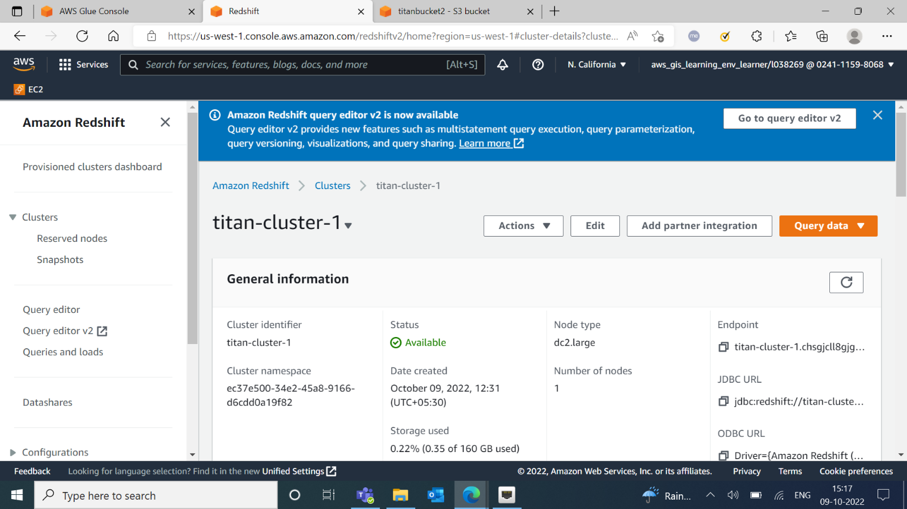

* Created Redshift cluster “titan-cluster-1”.

1. **Making Connection for query builder**

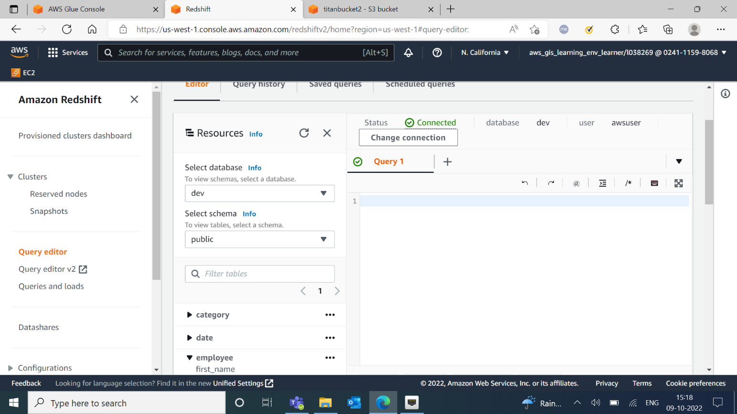

1. **Creating 1st crawler for S3 bucket**

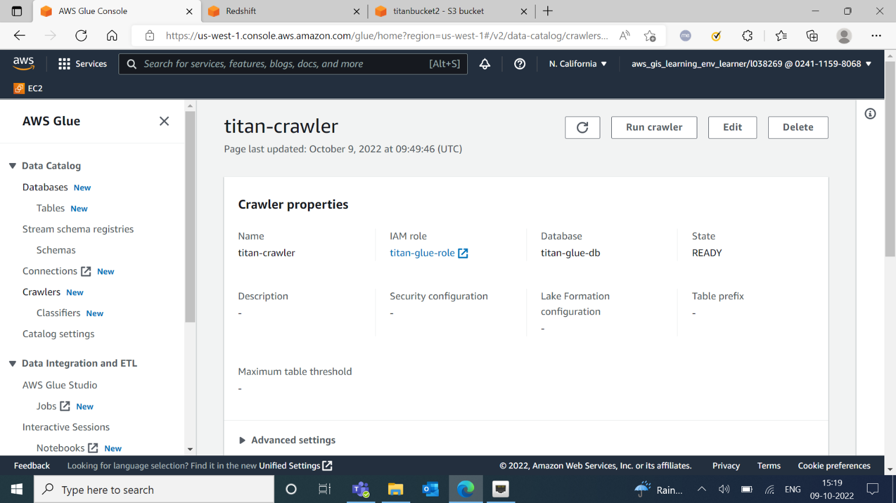

* Created 1st crawler for S3 bucket “titan-crawler”.

1. **Creating connection for Redshift**

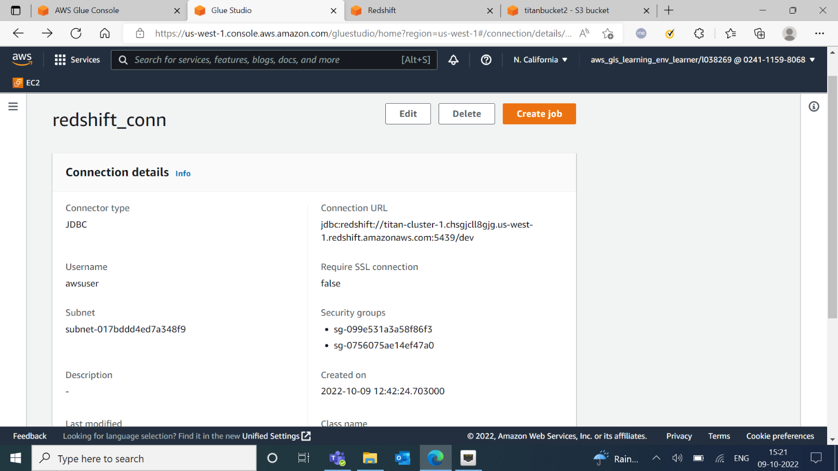

* Created connection for redshift.

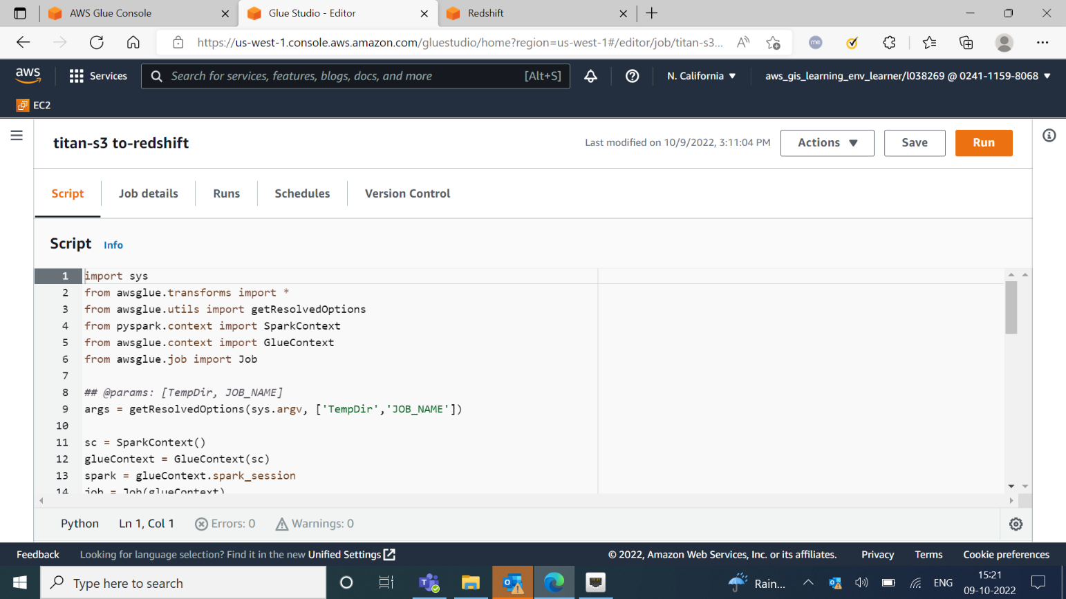

* Created a job for redshift.

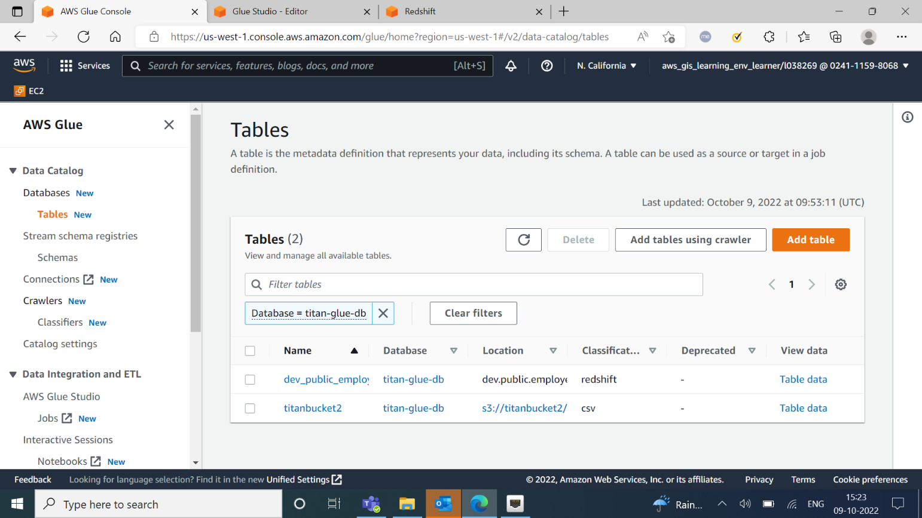

* After running the 2 crawlers 2 tables were created.

1. **Output**

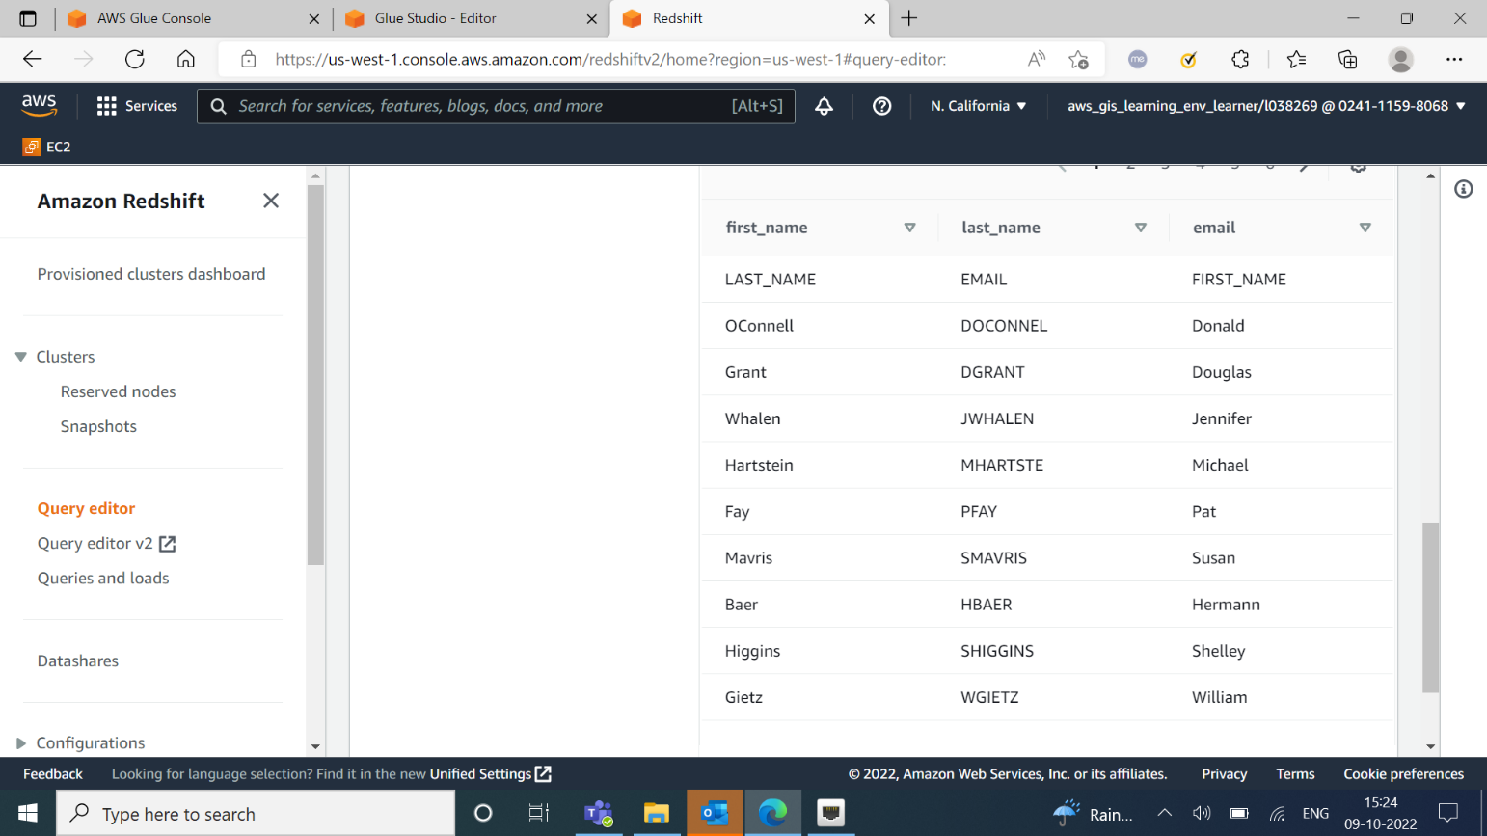

* Data imported into Redshift using Glue.